Loqate, A GBG Solution Release Notes
2019Q4.1 Minor Release
Table of Contents
Case Resolutions 3
Local API Improvements 3
EnhancedCountryTool 3
Certification Expiration Dates 4
Country Improvement Program (PDH) 5
Current Countries Completed PDH 5
Israel 5
Knowledge Base & Reference Data Updates 6
Installation Instructions 7
Standard GBG Loqate Installation (Multi-threaded) 7
Single-threaded GBG Loqate Installation 7
SFTP Server Contents 8
Need Help? 9

Case Resolutions
Please visit http://support.loqate.com/2019q4-1-resolved-cases/ for a list of cases resolved in this release.

If you would like more details on any of the solved cases listed, please contact support@loqate.com for further information.

Local API Improvements
Fix API hang issue when using EnhancedCountryTool

Follwing the 2019Q4.0 API release, when setting the server option EnhancedCountry Tool to True, the feature did not populate correctly. This issue existed for both Brazil and U.S. This was caused by using the wrong record object (runtime record vs original record) when tracking the short listed countries.

Preventative measures for this type of issue are in development now.

Certification Expiration Dates
If you have purchased either the CASS (USA) or AMAS (Australia) certified products, please be aware that the datasets have expiration dates set by the respective postal authorities. Please ensure that you have the latest library and data installed to avoid loss of service through these products.

Please check Install Manager for the latest versions of AMAS and CASS.
 | Loqate Release Date | Certification Expiry Date*
AMAS Data | 2019-11-21 | 2020-03-31
CASS Data | 2019-11-21 | 2020-02-28
*Certification Expiry Date is different from Loqate license key expiry date. The earliest expiry date will apply.

For more information on expiry date checking for CASS and AMAS, please refer “Usage expiration” section in https://support.loqate.com/documentation/local-apis/cass-overview-2/ and https://support.loqate.com/address-matching-approval-system-amas/

Country Improvement Program (PDH)
The following section will display the changes made during the country improvement program. For this quarter we’ve released improved datasets for the countries: Israel.

For more details on our Country Improvement Program, please visit the support site here.

Current Countries Completed PDH

COUNTRY | Date PDH Completed | Verification Level |  |  | COUNTRY | Date PDH Completed | Verification Level
ISRAEL | 2019-11 | L4 |  |  | SOUTH AFRICA | 2018-10 | L4
BELGIUM | 2019-10 | L4+ |  |  | AUSTRIA | 2018-10 | L4
GREECE | 2019-10 | L4 |  |  | BRAZIL | 2018-07 | L4
INDIA | 2019-10 | L4 |  |  | MEXICO | 2018-07 | L4
TURKEY | 2019-10 | L4 |  |  | CZECH REPUBLIC | 2018-04 | L4
ARGENTINA | 2019-07 | L4 |  |  | UNITED STATES | 2018-01 | L5
COLOMBIA | 2019-07 | L4 |  |  | JAPAN | 2018-01 | L4
ITALY | 2019-07 | L4 |  |  | DENMARK | 2018-01 | L5
THAILAND | 2019-07 | L4 |  |  | NORWAY | 2018-01 | L4
PERU | 2019-07 | L4 |  |  | GERMANY | 2017-11 | L4
SAN MARINO | 2019-07 | L4 |  |  | NETHERLANDS | 2017-10 | L4
HAITI | 2019-07 | L3- |  |  | NEW ZEALAND | 2017-10 | L5
NICARAGUA | 2019-07 | L3- |  |  | FRENCH POLYNESIA | 2017-10 | L3
QATAR | 2019-07 | L4 |  |  | FRANCE | 2017-07 | L4
UNITED ARAB EMIRATES | 2019-07 | L4 |  |  | SWEDEN | 2017-07 | L4
KOREA, REPUBLIC OF | 2019-04 | L4 |  |  | CANADA | 2017-04 | L5
PORTUGAL | 2019-04 | L4 |  |  | AUSTRALIA | 2017-04 | L5
SPAIN | 2019-04 | L4 |  |  | SWITZERLAND | 2017-01 | L4
MALAYSIA | 2019-04 | L4 |  |  | FINLAND | 2017-01 | L4
PHILIPPINES | 2019-04 | L4 |  |  | EGYPT | 2017-01 | L4
URUGUAY | 2019-04 | L4 |  |  | ANDORRA | 2017-01 | L4
ISLE OF MAN | 2019-04 | L5 |  |  | ECUADOR | 2017-01 | L4
GUERNSEY | 2019-04 | L5
JERSEY | 2019-04 | L5
LITHUANIA | 2019-04 | L4
SINGAPORE | 2018-10 | L4

Israel

Country Information | Description
ISO2 | IL
ISO3 | ISR
Address Format (Latin) | Organization  PostBox  SubBuilding Building  Premise Thoroughfare  DependentThoroughfare  DoubleDependentLocality  DependentLocality  PostalCode Locality
PDH | Yes
PDH completed date | 2019Q4.1
New Source | Updated postal code system to 7-digit format

 | Pre-PDH | Post-PDH
Reference Data | rd_IL_.lfs  rd_IL_ai.lfs  rd_IL_rg.lfs  rd_IL_geop.lfs  rd_IL_geop_rg.lfs | rd_IL_ggg.lfs  rd_IL_ggg_rg.lfs  rd_IL_vfy.lfs  rd_IL_vfy_ai.lfs

Starting with the 2019Q4.1 release, the postal code system was changed to the 7-digit format. Transliteration was updated to display the expected Hebrew characters when setting OutputScript to Native.

Before PDH | After PDH
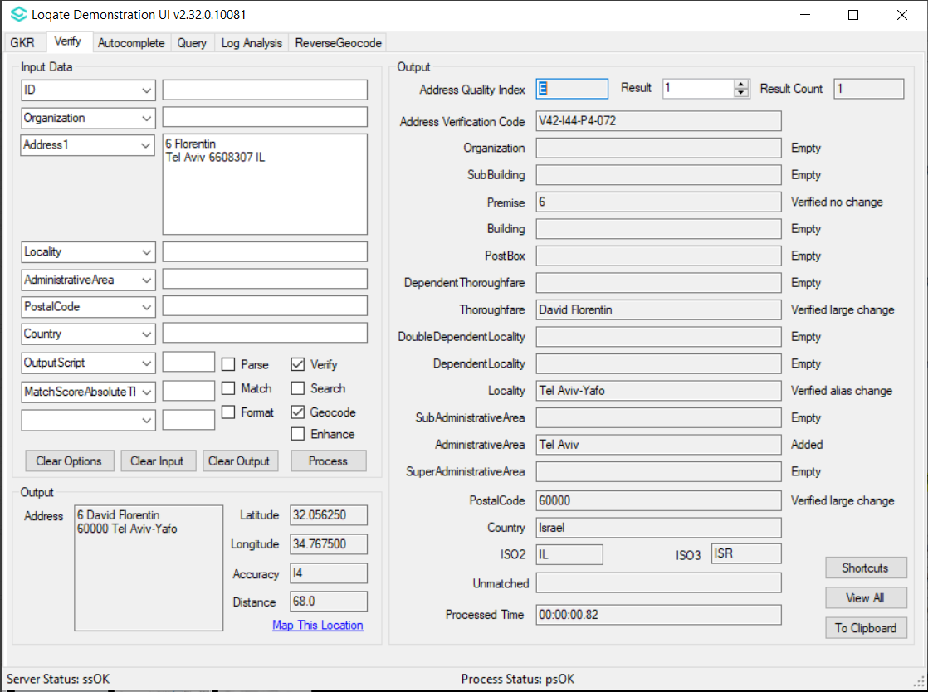  2019Q3.0 – Old 5-digit postal code returned. | 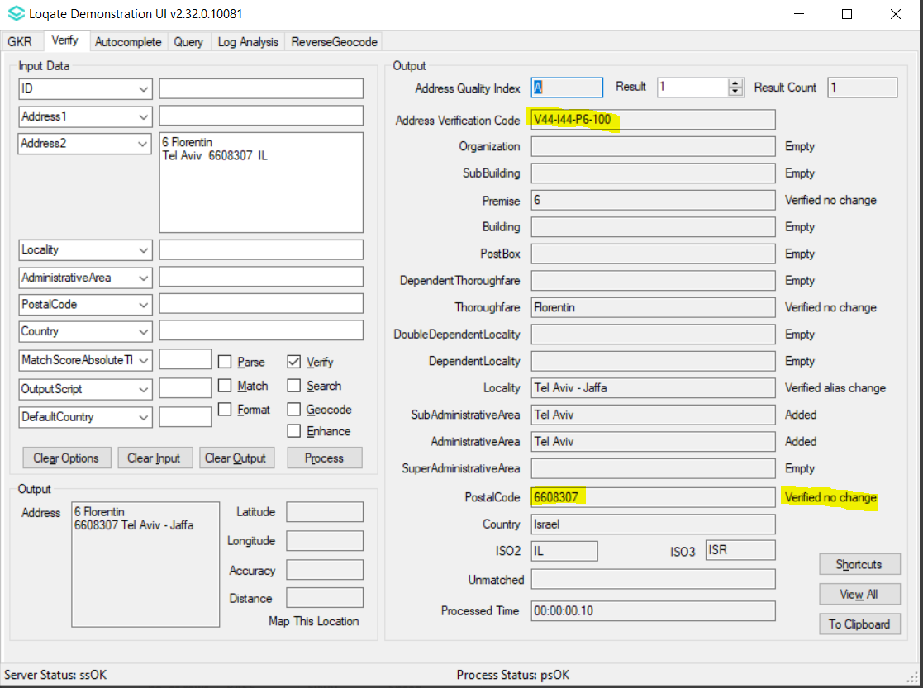  2019Q4.1 - New 7-digit postal code returned.
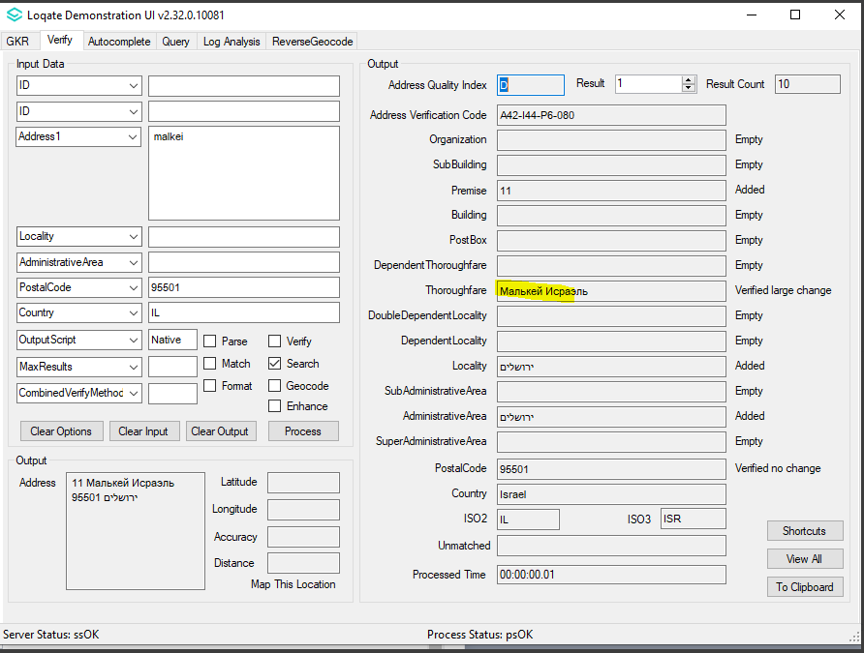  2019Q3.0 - Incorrect script (Russian character) returned when OutputScript set to Native. | 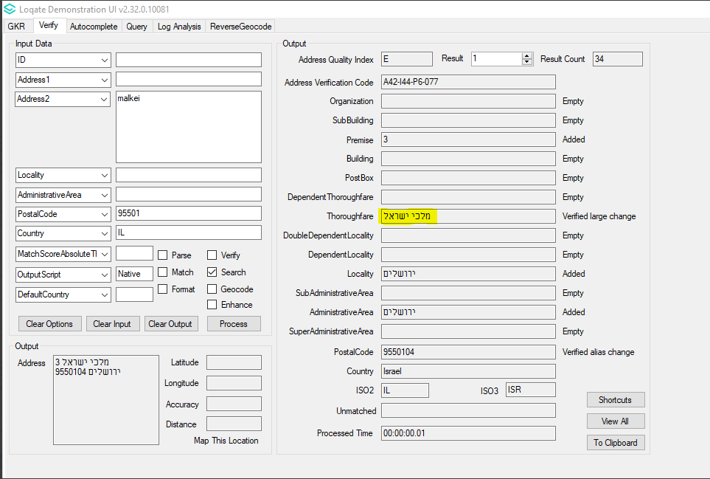  2019Q4.1 - Correct script (Hebrew character) returned when OutputScript set to Native.

Knowledge Base & Reference Data Updates
The table below shows which countries have been updated, and how, in this release.
If there is a PDH in the reference data column, this shows a country was included in the country improvement project.

- Reference Data = 16
- Lexicons = 6
- Context Rules = 1

COUNTRY NAME | ISO CODE | CONTEXT RULES | LEXICONS | REFERENCE DATA
ARGENTINA | AR |  | X
AMERICAN SAMOA | AS |  |  | X
BOUVET ISLAND | BV |  | X
BRAZIL | BR |  |  | X
CANADA | CA |  |  | X
MICRONESIA, FEDERATED STATES OF | FM |  |  | X
EGPYT | EG | X | X
UNITED KINGDOM | GB |  |  | X
GUERNSEY | GG |  |  | X
GUAM | GU |  |  | X
HEARD ISLAND AND MCDONALD ISLANDS | HM |  | X
ISLE OF MAN | IM |  |  | X
INDIA | IN |  | X
ISRAEL | IL |  | X | X
JERSEY | JE |  |  | X
MARSHALL ISLANDS | MH |  |  | X
NORTHERN MARIANA ISLANDS | MP |  |  | X
PUERTO RICO | PR |  |  | X
PALAU | PW |  |  | X
UNITED STATES | US |  |  | X
VIRGIN ISLANDS, U.S. | VI |  |  | X

Installation Instructions
The 2019Q4.1 release makes improvements to the performance of the verification process and the quality of the results.

Please remember to update both the program files and the reference data. The improvements are tied to the data in the Global Knowledge Repository and the Local API. If you need any assistance with the upgrade of the Local API or the data update process, please contact GBG Loqate Support.

The setup wizard for the Local API can be obtained from our SFTP server. Please contact your account manager to retrieve the SFTP information. If you do not know who your account manager is, please contact the support team at support@loqate.com.

GBG Loqate data packs can be downloaded and installed using the Install Manager. This is a component you will need to select during the installation of the Local API as shown below.

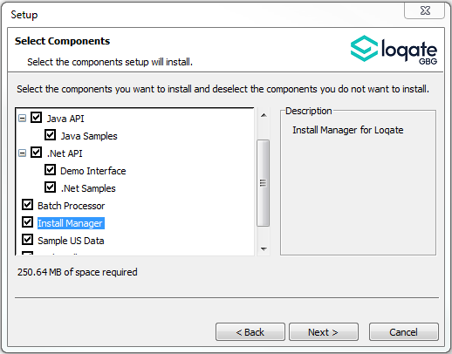

Standard GBG Loqate Installation (Multi-threaded)
- Download the contents of the 2019Q4.1/AppInstaller directory.
- Check the MD5 checksums to ensure that the download has been successful.
- Run the relevant Loqate Local API installer. Please note you may need to add execute privileges to the relevant installer when using Linux. Make sure the option “Install Manager” is selected for installation.
- Execute the Install Manager script (InstallManager.bat on Windows and InstallManager.sh on other Linux/Unix platforms) and install the data. For further details, please review the 2019Q4.1 Installation Instructions document.
- Run the relevant Global Knowledge Repository installer. Please note you may need to add execute privileges when using Linux.

Single-threaded GBG Loqate Installation
- Download the contents of the 2019Q4.1/STAppInstaller directory.
- Check the MD5 checksums to ensure that the download has been successful.
- Run the relevant Loqate Local API installer. Please note you may need to add execute privileges to the relevant installer when using Linux. Make sure the option “Install Manager” is selected for installation.
- Execute the InstallManager script (InstallManager.bat on Windows and InstallManager.sh on other Linux/Unix platforms) and install the data. For further details, please review the 2019Q4.1 Installation Instructions document.
- Run the relevant Global Knowledge Repository installer. Please note you may need to add execute privileges when using Linux.

SFTP Server Contents
On the GBG Loqate SFTP server, you will find the following items:
- AppInstaller: The folder which contains the Loqate Local API installer
- loqate_installer_aix: The AIX Loqate Local API installer
- loqate_installer_hpux: The HP-UX Loqate Local API installer
- loqate_installer_solaris_x86: The Solaris x86 Loqate Local API installer
- loqate_installer_sparc: The Solaris SPARC Loqate Local API installer
- loqate_installer_x86: The Linux 32-bit Loqate Local API installer
- loqate_installer_x86-cpp5: The Linux 32-bit C++ v5 Local API Loqate library installer
- loqate_installer_x86_64: The Linux 64-bit Loqate Local API installer
- setup.exe: The Windows 32-bit Loqate Local API installer
- setup_x64.exe: The Windows 64-bit Loqate Local API installer
- AppInstaller-md5.txt : Contains the checksums of the files in the folder
- STAppInstaller: The folder which contains the Loqate Local API installer for single-threaded libraries
- loqate_installer_aix: The AIX Loqate Local API installer
- loqate_installer_hpux: The HP-UX Loqate Local API installer
- loqate_installer_solaris_x86: The Solaris x86 Loqate Local API installer
- loqate_installer_sparc: The Solaris SPARC Loqate Local API installer
- loqate_installer_x86: The Linux 32-bit Loqate Local API installer
- loqate_installer_x86-cpp5: The Linux 32-bit C++ v5 Local API Loqate library installer
- loqate_installer_x86_64: The Linux 64-bit Loqate Local API installer
- AppInstaller-md5.txt : Contains the checksums of the files in the folder
- STAppInstaller-md5.txt : Contains the checksums of the files in the folder
- OSGi: The folder which contains the OSGi bundle for the Loqate Local API
- loqate-osgi-1.0.0.0.jar: The OSGi bundle for Loqate Local API installer
- osgi-md5.txt: Contains the checksums of the files in the folder
- Rawfiles: The folder which contains the Loqate Local API files in the following subfolders
- aix: The AIX Loqate Local API library files
- hp-ux: The HP-UX Loqate Local API library files
- solaris_x86: The Solaris x86 Loqate Local API library files
- sparc: The Solaris SPARC Loqate Local API library files
- linux32: The Linux 32-bit Loqate Local API library files
- linux32-cpp5: The Linux 32-bit C++ v5 Loqate Local API library files
- linux64: The Linux 64-bit Loqate Local API library files
- win64: The Windows 32-bit Loqate Local API library files
- win32: The Windows 64-bit Loqate Local API library files

Need Help?
Many answers to your questions may be found in our support pages. For additional information, please visit the support site. Below are a list of useful links.

- Support Home Page: http://support.loqate.com
- Getting Started: https://support.loqate.com/getting-started/
- Local APIs: http://support.loqate.com/support/local-apis/
- Field Descriptions: http://support.loqate.com/support/fielddescrip/
- Server and Process Options: http://support.loqate.com/support/options/
- System Requirements: http://support.loqate.com/system-requirements/
If you have any general questions, issues, or enhancement request you’d like to share with us, please contact our support team at: support@loqate.com.

