Loqate, A GBG Solution Release Notes
2019Q4.0 Major Release
Table of Contents
Case Resolutions 3
Local API Improvements 3
Native Output 3
Over-populating Output 4
Certification Expiration Dates 5
Country Improvement Program (PDH) 6
Current Countries Completed PDH: 6
Verification Level Improvement 7
Coverage & Completeness 7
Belgium 8
Greece 9
India 11
Turkey 13
Knowledge Base & Reference Data Updates 15
Installation Instructions 20
Standard GBG Loqate Installation (Multi-threaded) 20
Single-threaded GBG Loqate Installation 20
SFTP Server Contents 21
Need Help? 22

Important Note: To install PDH countries, we recommend to create a new folder or use backup files option in Install Manager. This will help ensure the correct files required for PDH countries are installed.

Case Resolutions
Please visit http://support.loqate.com/2019q4-0-resolved-cases/ for a list of cases resolved in this release.

If you would like more details on any of the solved cases listed, please contact support@loqate.com for further information.

Local API Improvements

Native Output
The 2019Q4.0 API makes improvements in the address output format when using the native OutputScript server option.

In the 2019Q3.0 API, the address output may display incorrect native characters in the locality field, this is now resolved in the 2019Q4.0 API.

The 2019Q4.0 API also resolves the inconsistent display where the “address output format” will show as native but the “delivery address” displays Latin.

See below screenshots for examples.

2019Q3.0 | 2019Q4.0
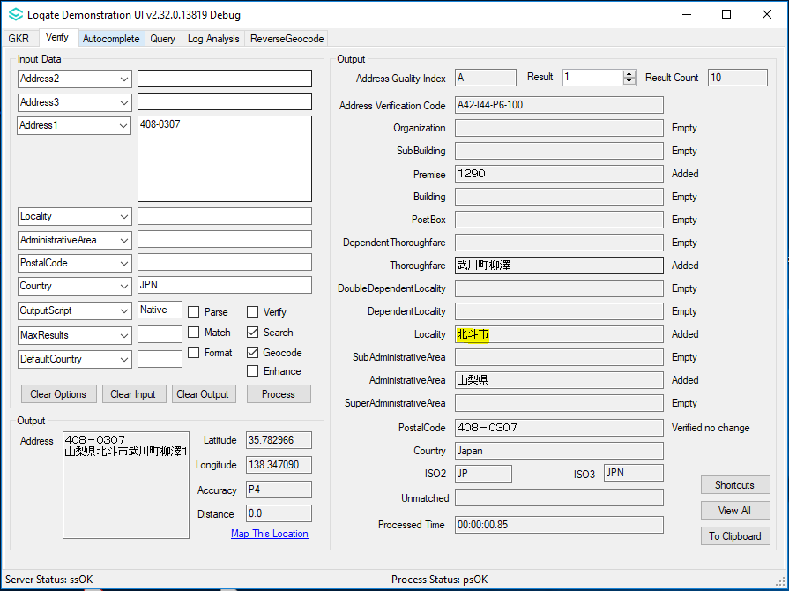  2019Q3.0: One or more than one of the fields might contain incorrect native character(s) (in this example is locality). | 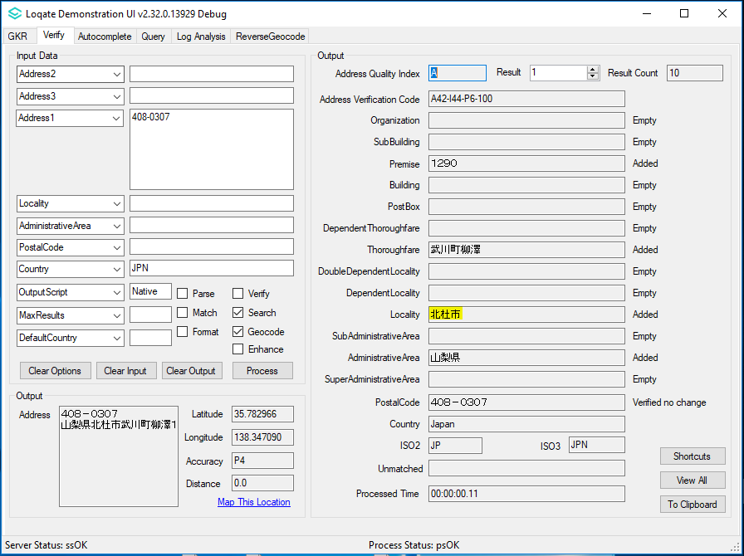  2019Q4.0: The output (locality) has been fixed using the correct native character.

2019Q3.0 | 2019Q4.0
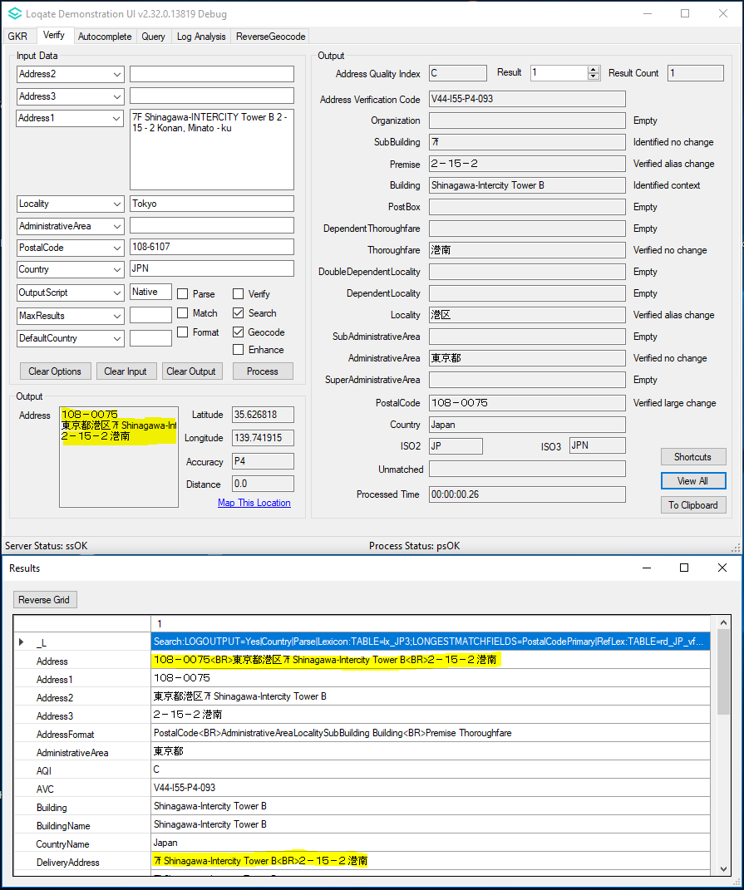  2019Q3.0: Address output format is not consistent, where the "Address"'s format is native but the "DeliveryAddress"'s Format is Latin. | 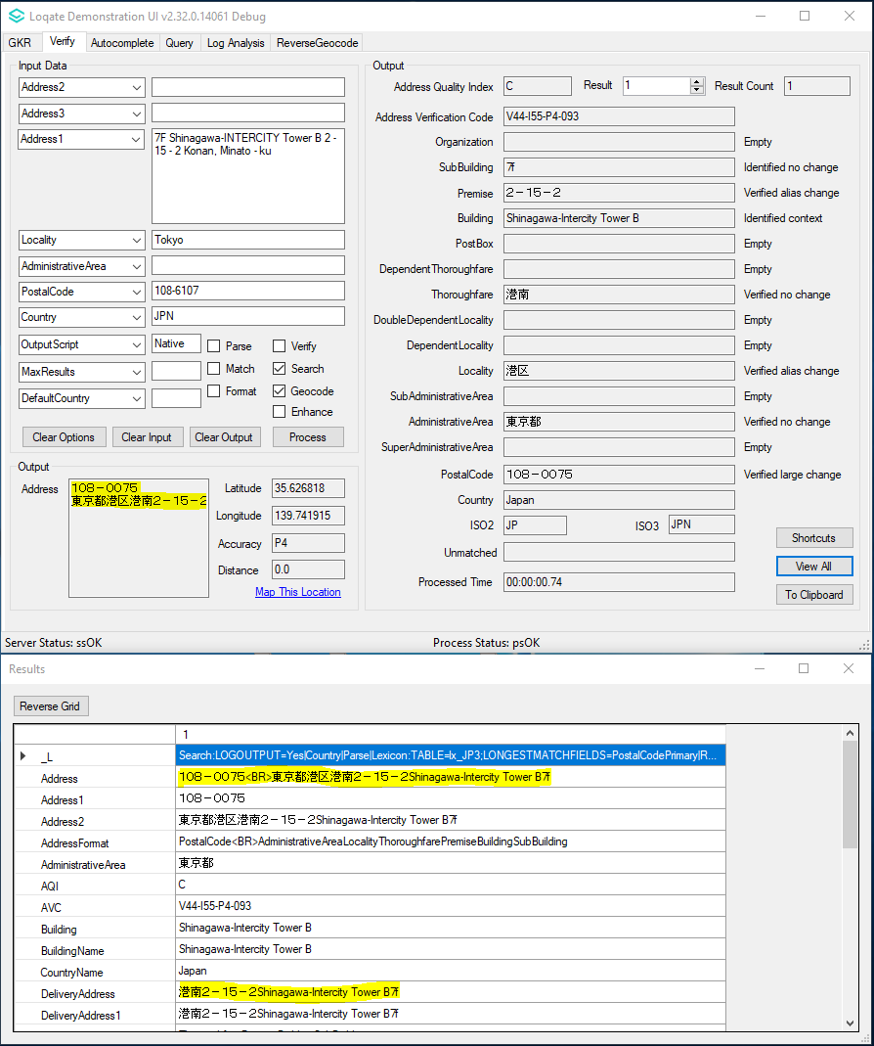  2019Q4.0: The format of both "Address" and DeliveryAddress" is native for consistency.

Over-populating Output
In the 2019Q3.0 API, certain addresses maybe over-populating by including extra sub-building information. The 2019Q4.0 API removes the incorrect addition of subbuilding information.

2019Q3.0 | 2019Q4.0
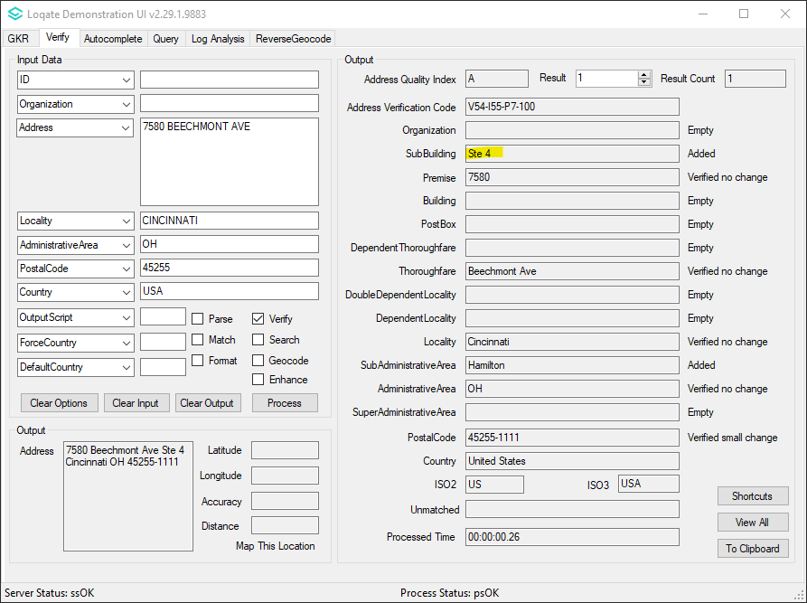  2019Q3.0: SubBuilding is added in output | 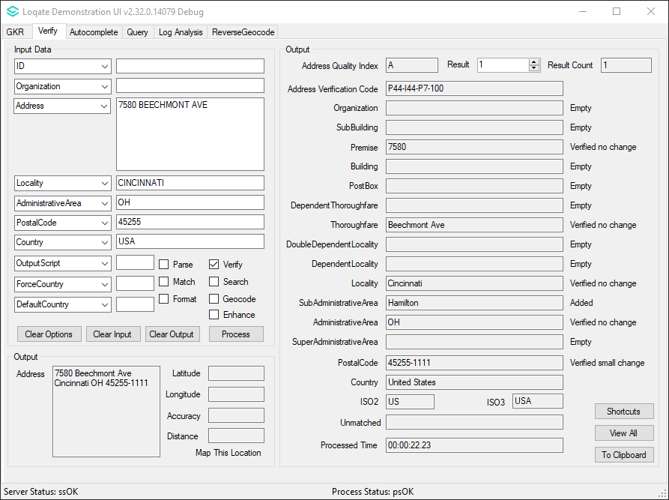  2019Q4.0: SubBuilding now has been removed from the output

Certification Expiration Dates
If you have purchased either the CASS (USA) or AMAS (Australia) certified products, please be aware that the datasets have expiration dates set by the respective postal authorities. Please ensure that you have the latest library and data installed to avoid loss of service through these products.

Please check Install Manager for the latest versions of AMAS and CASS.
 | Loqate Release Date | Certification Expiry Date*
AMAS Data | 2019-09-03 | 2019-12-31
CASS Data | 2019-10-11 | 2020-01-28
*Certification Expiry Date is different from Loqate license key expiry date. The earliest expiry date will apply.

For more information on expiry date checking for CASS and AMAS, please refer “Usage expiration” section in https://support.loqate.com/documentation/local-apis/cass-overview-2/ and https://support.loqate.com/address-matching-approval-system-amas/

Country Improvement Program (PDH)
The following section will display the changes made during the country improvement program. For this quarter we’ve released improved datasets for the countries: Belgium, Greece, India, and Turkey.

For more details on our Country Improvement Program, please visit the support site here.

Current Countries Completed PDH

COUNTRY | Date PDH Completed | Verification Level |  |  | COUNTRY | Date PDH Completed | Verification Level
BELGIUM | 2019-10 | L4+ |  |  | SOUTH AFRICA | 2018-10 | L4
GREECE | 2019-10 | L4 |  |  | AUSTRIA | 2018-10 | L4
INDIA | 2019-10 | L4 |  |  | BRAZIL | 2018-07 | L4
TURKEY | 2019-10 | L4 |  |  | MEXICO | 2018-07 | L4
ARGENTINA | 2019-07 | L4 |  |  | CZECH REPUBLIC | 2018-04 | L4
COLOMBIA | 2019-07 | L4 |  |  | UNITED STATES | 2018-01 | L5
ITALY | 2019-07 | L4 |  |  | JAPAN | 2018-01 | L4
THAILAND | 2019-07 | L4 |  |  | DENMARK | 2018-01 | L5
PERU | 2019-07 | L4 |  |  | NORWAY | 2018-01 | L4
SAN MARINO | 2019-07 | L4 |  |  | GERMANY | 2017-11 | L4
HAITI | 2019-07 |  |  |  | NETHERLANDS | 2017-10 | L4
NICARAGUA | 2019-07 |  |  |  | NEW ZEALAND | 2017-10 | L5
QATAR | 2019-07 |  |  |  | FRENCH POLYNESIA | 2017-10 | L3
UNITED ARAB EMIRATES | 2019-07 |  |  |  | FRANCE | 2017-07 | L4
KOREA, REPUBLIC OF | 2019-04 | L4 |  |  | SWEDEN | 2017-07 | L4
PORTUGAL | 2019-04 | L4 |  |  | CANADA | 2017-04 | L5
SPAIN | 2019-04 | L4 |  |  | AUSTRALIA | 2017-04 | L5
MALAYSIA | 2019-04 | L4 |  |  | SWITZERLAND | 2017-01 | L4
PHILIPPINES | 2019-04 | L4 |  |  | FINLAND | 2017-01 | L4
URUGUAY | 2019-04 | L4 |  |  | EGYPT | 2017-01 | L4
ISLE OF MAN | 2019-04 | L5 |  |  | ANDORRA | 2017-01 | L4
GUERNSEY | 2019-04 | L5 |  |  | ECUADOR | 2017-01 | L4
JERSEY | 2019-04 | L5
LITHUANIA | 2019-04 | L4
SINGAPORE | 2018-10 | L4

Verification Level Improvement
The uplift range describes the improvements made by the PDH process. For example, you may see a record returning a level 2 (locality level) prior to PDH and a level 4 (premise level) after PDH; these types of changes demonstrate a positive improvement due to better alignment and cleaner structures in the reference data.

In cases where a record does the opposite, the enhanced dataset may be resolving a previously incorrect or false result.

These changes are dependent on the amount of sample data available.

Coverage & Completeness
For countries using existing data sources, these are unlikely to show any big changes to the total number of deliverable records. Many improvements in datasets will be based around field/value alignments and corrections to the geography hierarchy.

Level | Definition
5 | Delivery Point (PostBox or SubBuilding)
4 | Premise (Premise or Building)
3 | Thoroughfare
2 | Locality or PostalCode
1 | AdministrativeArea
0 | None

Belgium: When comparing to 2019Q3.0, there is an overall uplift of ~1 % to 6%. An average of 2% of the data have been removed from level 2; within the 2% level 2 addresses removed, 4% increased to level 4 verification.

Greece: When comparing to 2019Q3.0, there is an overall uplift of ~3.5% to 18%. An average of 15% of the data have been removed from level 2; within the 15% level 2 addresses removed, 12% increased to level 4 verification.

India: When comparing to 2019Q3.0, there is an overall uplift of ~16% to 22%. An average of 15% of the data have been removed from level 3; within the 15% level 3 addresses removed, 14% increased to level 4 verification.

Turkey: When comparing to 2019Q3.0, there is an overall uplift of ~ 17% to 41%. An average of 24% of the data have been removed from level 2; within the 24% level 3 addresses removed, 14% increased to level 4 verification.

Belgium

Country Information | Description
ISO2 | BE
ISO3 | BEL
Address Format (Latin) | Organization  PostBox  Building SubBuilding  Thoroughfare Premise  DependentThoroughfare  DoubleDependentLocality  DependentLocality  PostalCode Locality
PDH | Yes
PDH completed date | 2019Q4.0
New Source | No

Files Used | Pre-PDH | Post-PDH
Reference Data | rd_BE_.lfs  rd_BE_ai.lfs  rd_BE_rg.lfs  rd_BE_geop.lfs  rd_BE_geop_rg.lfs | rd_BE_ggg.lfs  rd_BE_ggg_rg.lfs  rd_BE_ggg_r.lfs  rd_BE_vfy.lfs  rd_BE_vfy_ai.lfs

The 2019Q4.0 makes improvements to parsing. Some cases may have incorrect values in either the premise or sub-building fields.

With the 2019Q3.0 data, some cases may display the wrong premise value in the premise field. 2019Q4.0 data will now capture the correct premise values.

Additionally, the 2019Q3.0 data may have parsed the thoroughfare into building field when the building building type key words are present.

Greece

Country Information | Description
ISO2 | GR
ISO3 | GRC
Address Format (Latin) | Organization  PostBox  Building SubBuilding  Thoroughfare PremiseExtra Premise  DependentThoroughfare  DoubleDependentLocality  DependentLocality  PostalCode Locality
PDH | Yes
PDH completed date | 2019Q4.0
New Source | No

Files Used | Pre-PDH | Post-PDH
Reference Data | rd_GR_ggg.lfs  rd_GR_ggg_rg.lfs  rd_GR_vfy_ai.lfs  rd_GR_vfy.lfs | rd_GR_ggg.lfs  rd_GR_ggg_rg.lfs  rd_GR_vfy_ai.lfs  rd_GR_vfy.lfs

In 2019Q3.0 data certain thoroughfares could not be verified. Since the thoroughfares couldn’t be verified, the addresses returned a P2 AVC result. 2019Q4.0 resolves this issue and now provides a valid thoroughfare and returns V4 AVC code.

2019Q4.0 data also improves the data alighment within the dependent locality and building fields.

See screenshots below for example:

2019Q3.0 | 2019Q4.0
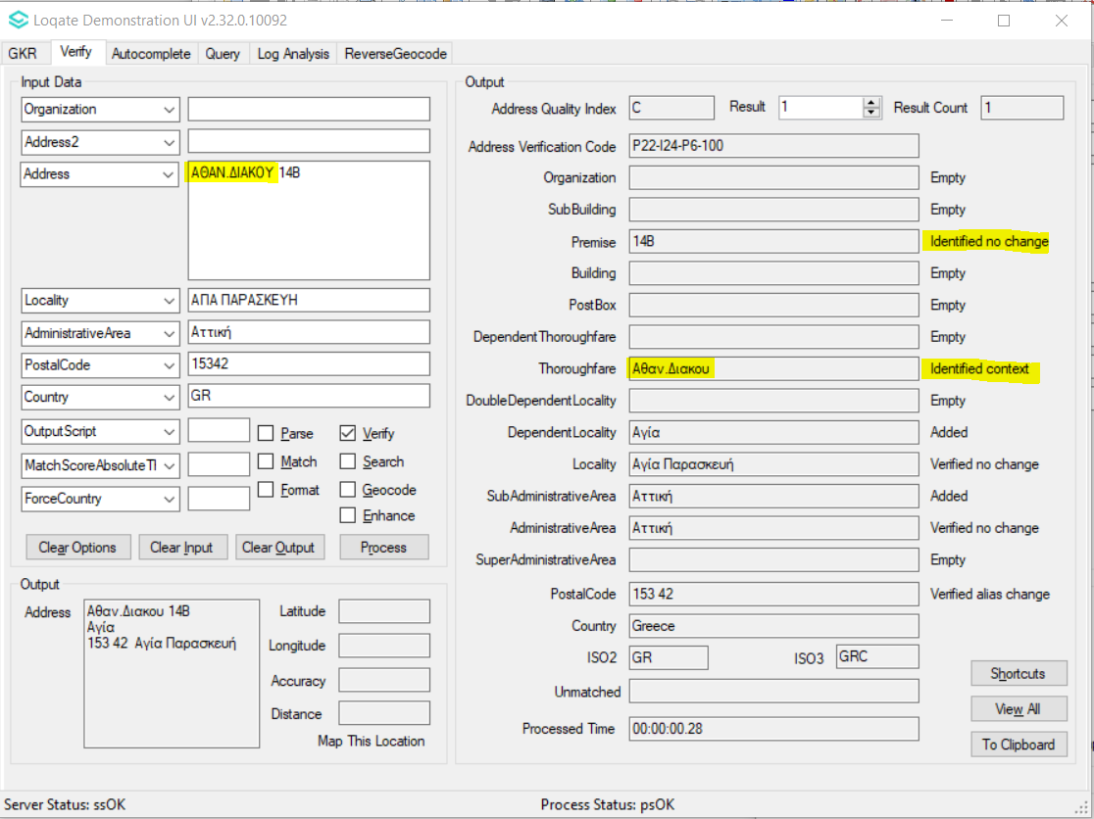  2019Q3.0: Thoroughfare not able to be verified. | 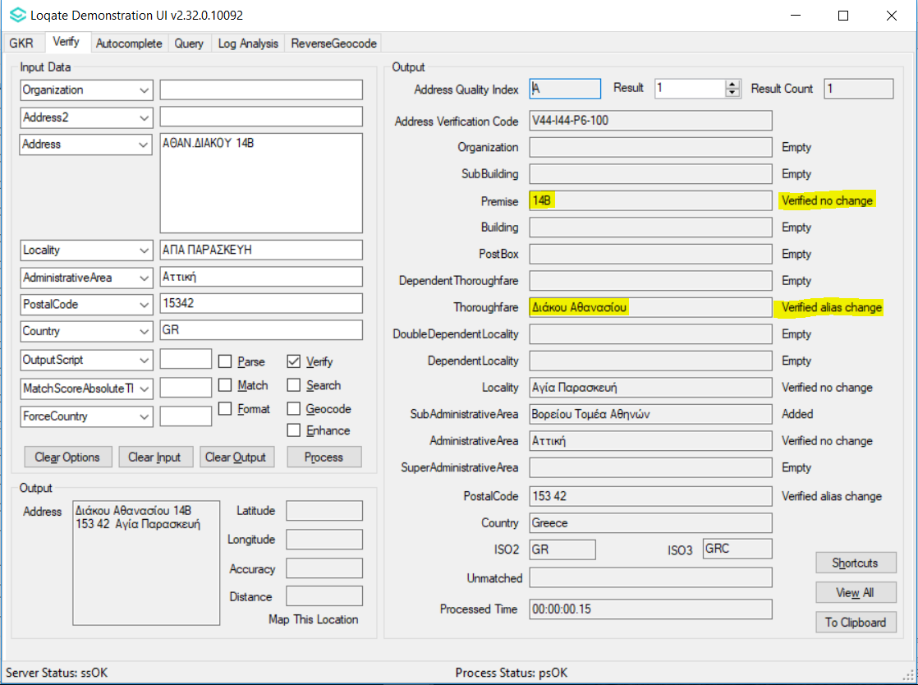  2019Q4.0: Thoroughfare and premise able to be verified and return V4
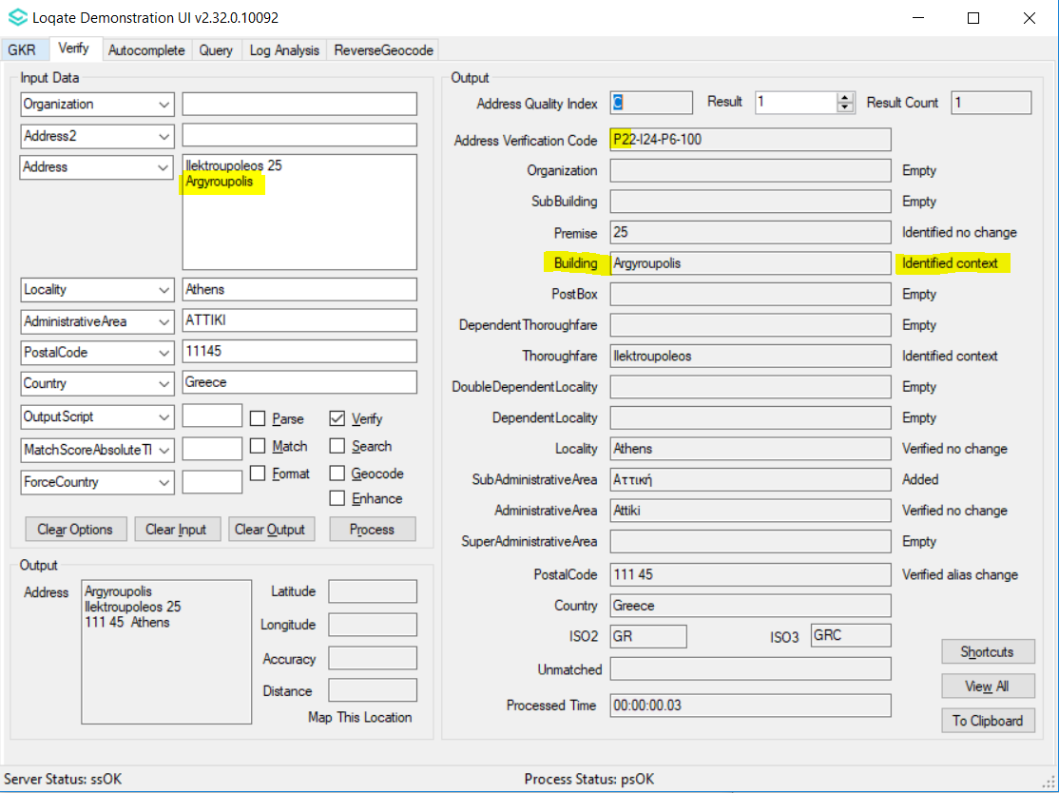  2019Q3.0: Dependent Locality wrongly parsed into Building field. | 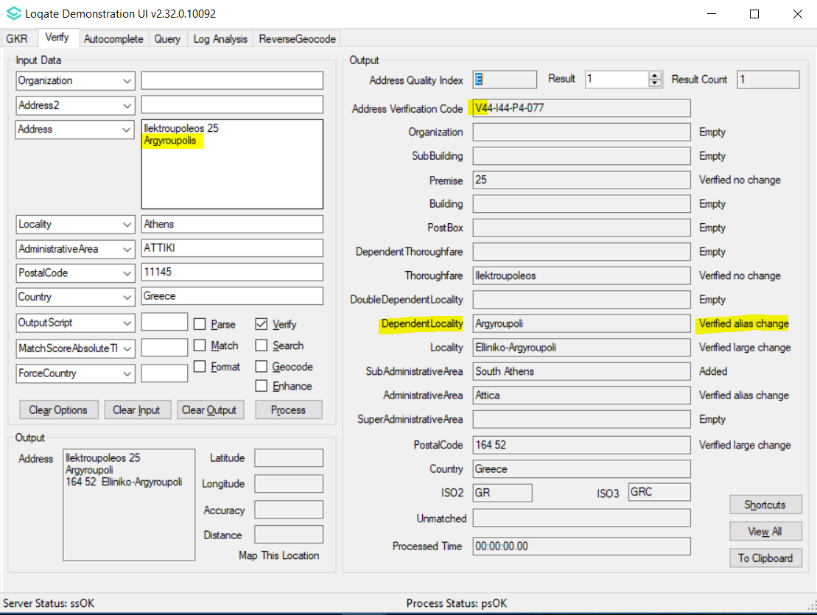  2019Q4.0: Dependent Locality able to parsed correctly and verified.

India

Country Information | Description
ISO2 | IN
ISO3 | IND
Address Format (Latin) | Organization  PostBox  SubBuilding Building  Premise Thoroughfare  DependentThoroughfare  DoubleDependentLocality  DependentLocality  Locality AdministrativeArea PostalCode
PDH | Yes
PDH completed date | 2019Q4.0
New Source | No

Files Used | Pre-PDH | Post-PDH
Reference Data | lx_IN.lfs  rd_IN.lfs  rd_IN_ai.lfs  rd_IN_geop.lfs  rd_IN_geop_rg.lfs  rd_IN_rg.lfs  pp_IN.txt  lx_IN_P.lfs  rd_IN.lfs  rd_IN_ai.lfs  rd_IN_f.lfs  rd_IN_m.lfs  rd_IN_rg.lfs  pp_IN.txt | lx_IN.lfs  rd_IN_vfy.lfs  rd_IN_vfy_ai.lfs  rd_IN_ggg.lfs  rd_IN_ggg_rg.lfs  rd_IN_ggg_r.lfs  pp_IN.txt

The 2019Q4.0 data provides improvement to verification with the organization and subbuilding values.

See screenshots below for examples.

2019Q3.0 | 2019Q4.0
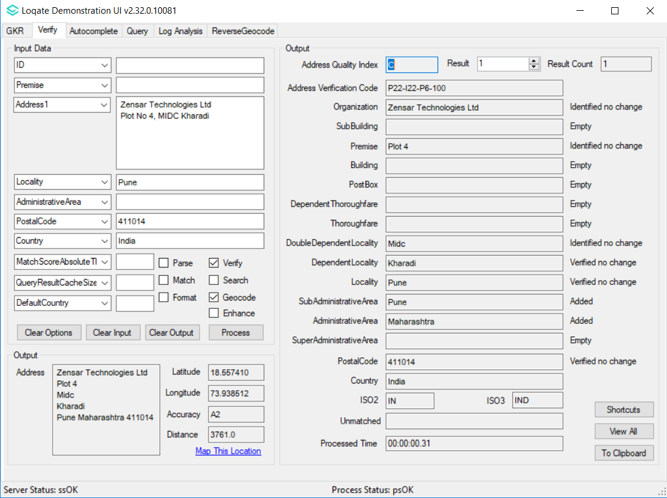  2019Q3.0: Organization not able to be verified. | 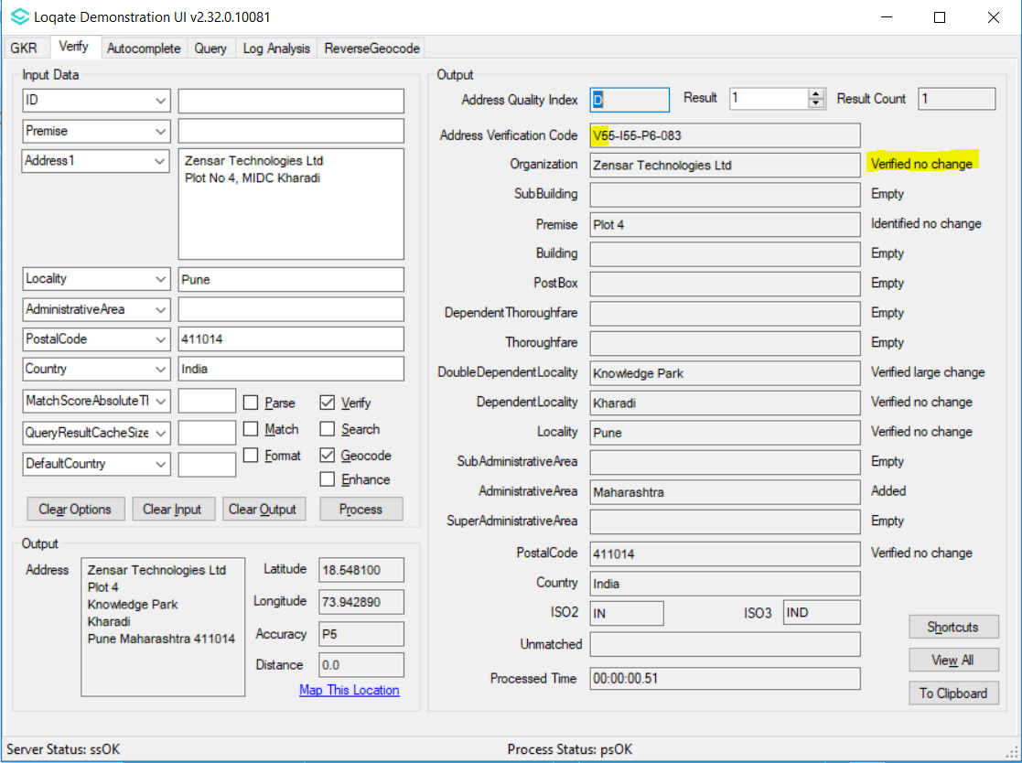  2019Q4.0: Organization able to be verified and return V5.

2019Q3.0 | 2019Q4.0
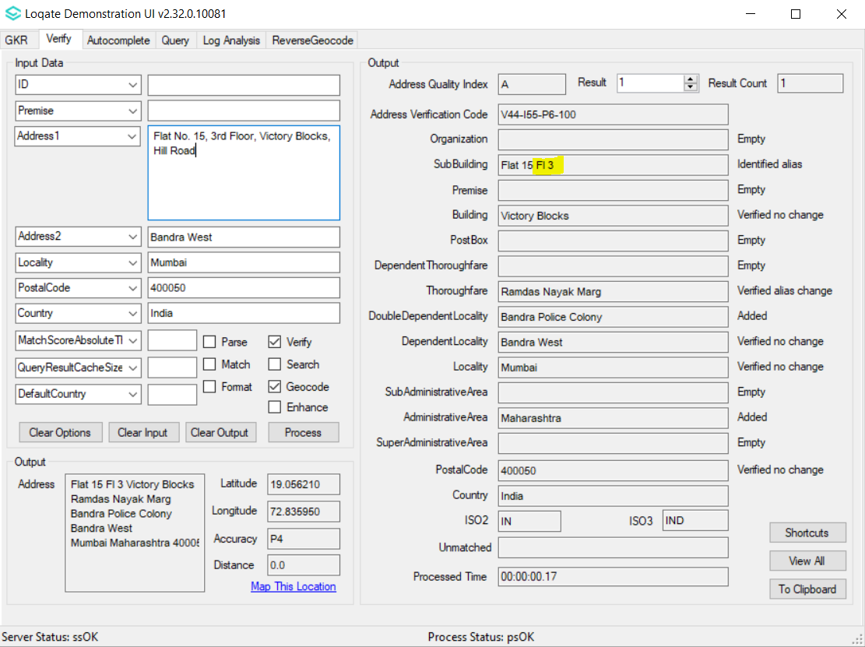  2019Q3.0: 'Floor' is abbreviated to 'Fl'. | 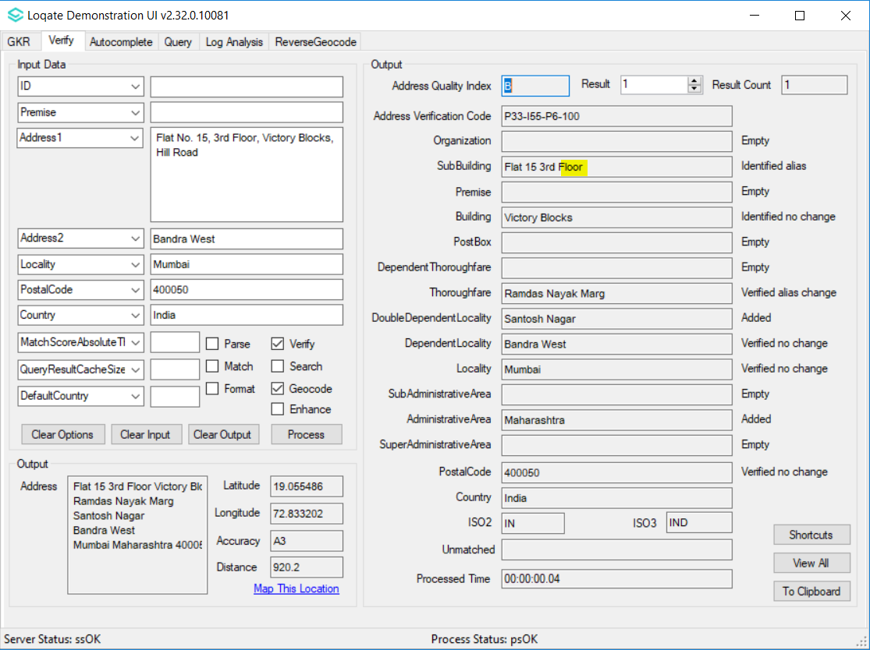  2019Q4.0: 'Floor' is maintained.

Turkey

Country Information | Description
ISO2 | TR
ISO3 | TUR
Address Format (Latin) | Organization  DoubleDependentLocality  DependentLocality  Thoroughfare Building Premise SubBuilding  PostBox  PostalCode Locality AdministrativeArea
PDH | Yes
PDH completed date | 2019Q4.0
New Source | No

Files Used | Pre-PDH | Post-PDH
Reference Data | rd_TR_geo.lfs  rd_TR_geop.lfs  rd_TR_geop_rg.lfs  rd_TR_geop_r.lfs  rd_TR_geo_rg.lfs  rd_TR_vfy_ai.lfs  rd_TR_vfy.lfs | rd_TR_ggg.lfs  rd_TR_ggg_rg.lfs  rd_TR_ggg_r.lfs  rd_TR_vfy_ai.lfs  rd_TR_vfy.lfs

2019Q4.0 data features improvements to the alignment with locality and subadministrativearea levels. The parisng is also improved within the locality fields.

See below screenshots for examples.

2019Q3.0 | 2019Q4.0
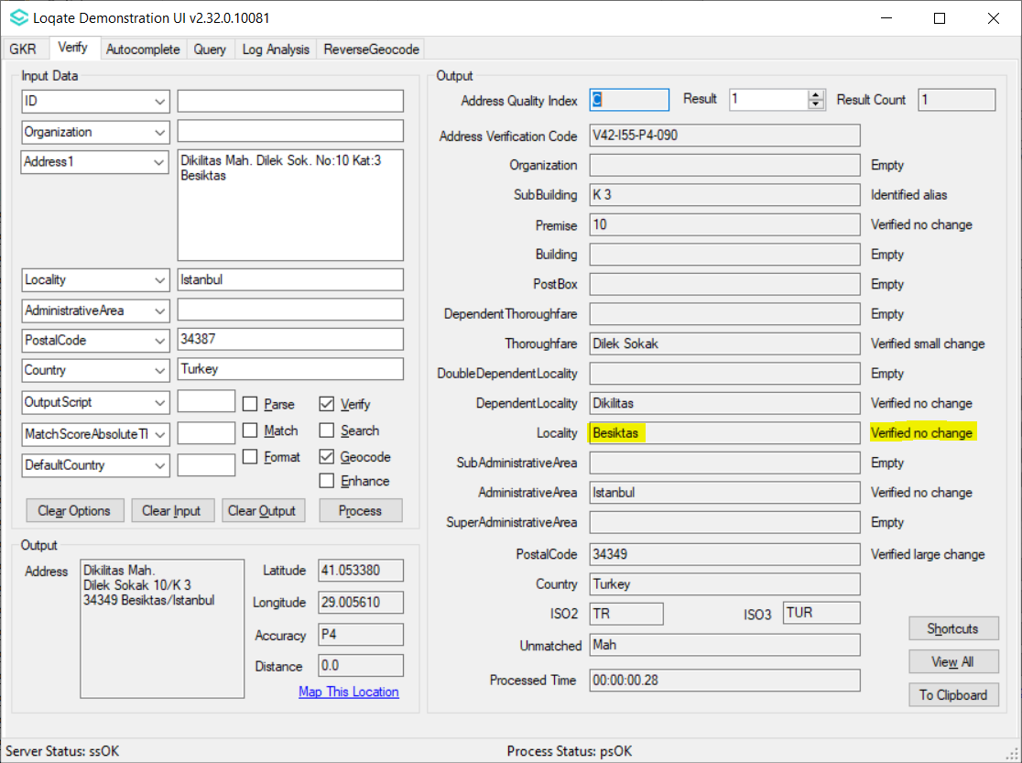  2019Q3.0: 'Besiktas' was at Locality level. | 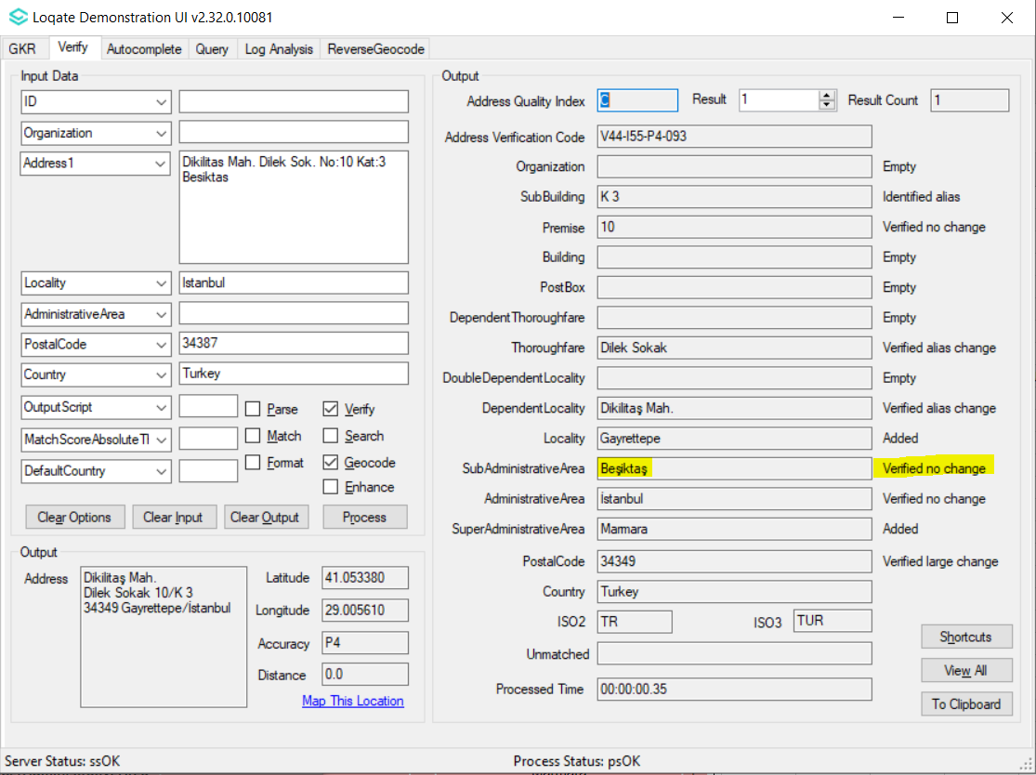  2019Q4.0: 'Besiktas' is re-aligned to SubAdministrativeArea level.
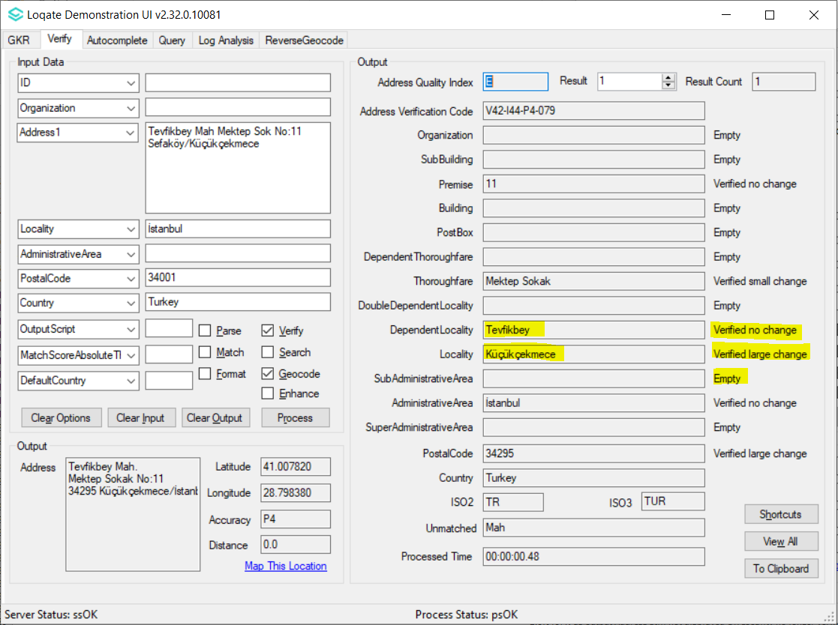  2019Q3.0: Incorrect Locality returned. | 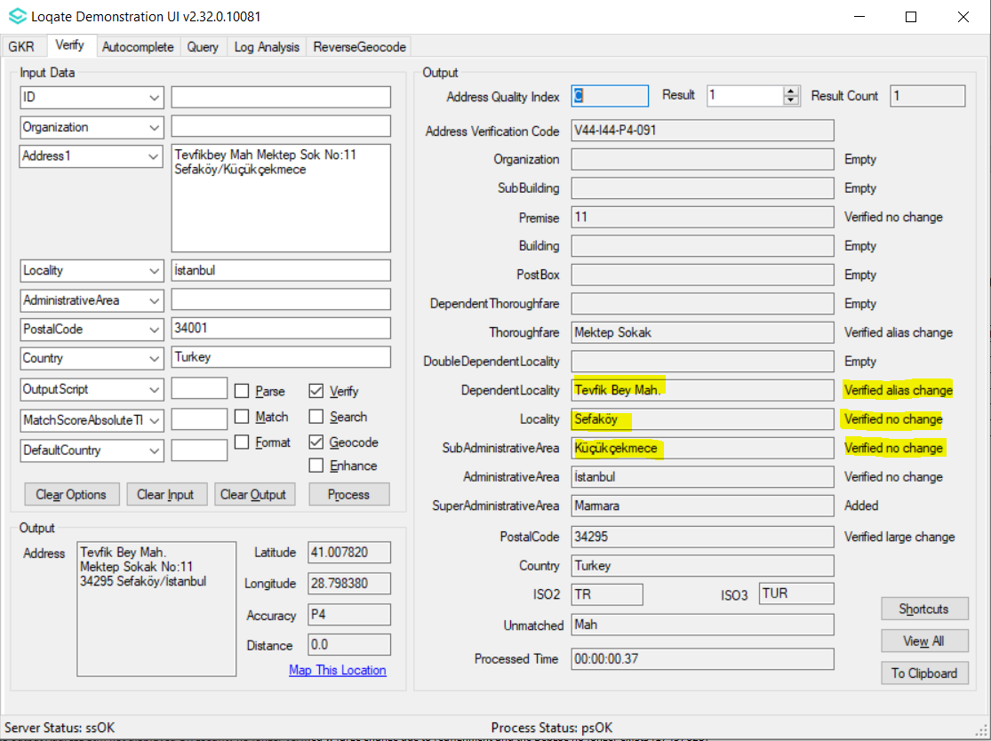  2019Q4.0: Locality correctly parsed and verified.
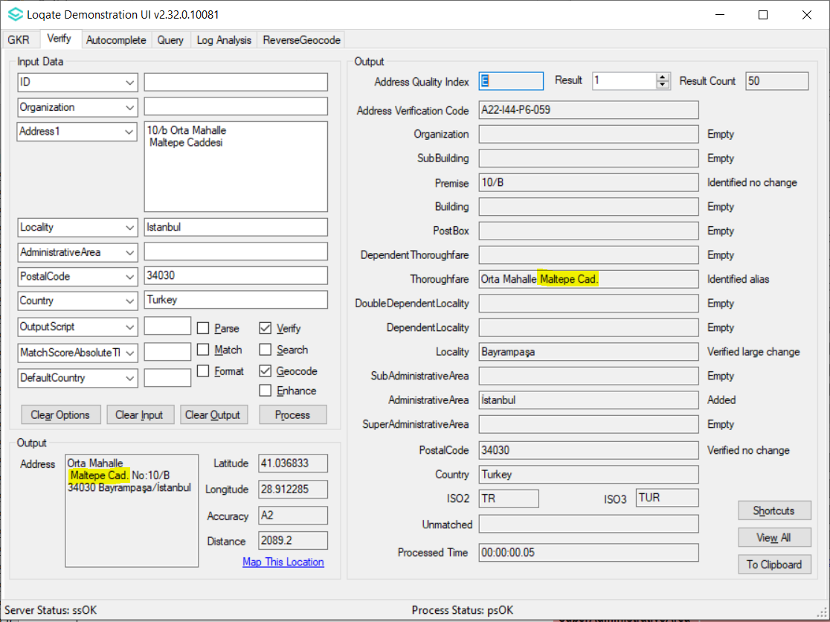  2019Q3.0: 'Caddesi' is abbreviated to 'Cad'. | 2019Q4.0: 'Caddesi' is maintained.

Knowledge Base & Reference Data Updates
The table below shows which countries have been updated, and how, in this release.
If there is a PDH in the reference data column, this shows a country was included in the country improvement project.

- Reference Data = 185 countries (new PDH: Belgium, Greece, India, Turkey)
- Lexicons = 13 countries
- Context Rules = 9 countries

COUNTRY NAME | ISO CODE | CONTEXT RULES | LEXICONS | REFERENCE DATA
ALBANIA | AL |  |  | X
ALGERIA | DZ |  |  | X
AMERICAN SAMOA | AS |  |  | X
ANGOLA | AO |  |  | X
ANGUILLA | AI |  |  | X
ANTIGUA AND BARBUDA | AG |  |  | X
ARGENTINA | AR |  | X
ARMENIA | AM |  |  | X
ARUBA | AW |  |  | X
AZERBAIJAN | AZ |  |  | X
BAHAMAS | BS |  |  | X
BANGLADESH | BD |  |  | X
BARBADOS | BB |  |  | X
BELGIUM | BE | X | X | PDH
BELIZE | BZ |  |  | X
BENIN | BJ |  |  | X
BERMUDA | BM |  |  | X
BHUTAN | BT |  |  | X
BOLIVIA, PLURINATIONAL STATE OF | BO |  |  | X
BONAIRE, SINT EUSTATIUS AND SABA | BQ |  |  | X
BOSNIA AND HERZEGOVINA | BA |  |  | X
BOTSWANA | BW |  |  | X
BOUVET ISLAND | BV |  |  | X
BRITISH INDIAN OCEAN TERRITORY | IO |  |  | X
BRUNEI DARUSSALAM | BN |  |  | X
BURKINA FASO | BF |  |  | X
BURUNDI | BI |  |  | X
CAMBODIA | KH |  |  | X
CAMEROON | CM |  |  | X
CANADA | CA | X | X | X
CAPE VERDE | CV |  |  | X
CAYMAN ISLANDS | KY |  |  | X
CENTRAL AFRICAN REPUBLIC | CF |  |  | X
CHAD | TD |  |  | X
CHINA | CN |  | X
CHRISTMAS ISLAND | CX |  |  | X
COCOS (KEELING) ISLANDS | CC |  |  | X
COMOROS | KM |  |  | X
CONGO | CG |  |  | X
CONGO, THE DEMOCRATIC REPUBLIC OF THE | CD |  |  | X
COOK ISLANDS | CK |  |  | X
COSTA RICA | CR |  |  | X
Côte d'Ivoire | CI |  |  | X
CROATIA | HR |  |  | X
CUBA | CU |  |  | X
Curaçao | CW |  |  | X
CYPRUS | CY |  |  | X
CZECH REPUBLIC | CZ | X | X
DJIBOUTI | DJ |  |  | X
DOMINICA | DM |  |  | X
DOMINICAN REPUBLIC | DO |  |  | X
EL SALVADOR | SV |  |  | X
EQUATORIAL GUINEA | GQ |  |  | X
ERITREA | ER |  |  | X
ESTONIA | EE |  |  | X
ESWATINI | SZ |  |  | X
ETHIOPIA | ET |  |  | X
FALKLAND ISLANDS (MALVINAS) | FK |  |  | X
FAROE ISLANDS | FO |  |  | X
FIJI | FJ |  |  | X
FRENCH GUIANA | GF |  |  | X
FRENCH SOUTHERN TERRITORIES | TF |  |  | X
GABON | GA |  |  | X
GAMBIA | GM |  |  | X
GEORGIA | GE |  |  | X
GHANA | GH |  |  | X
GIBRALTAR | GI |  |  | X
GREECE | GR |  | X | PDH
GRENADA | GD |  |  | X
GUADELOUPE | GP |  |  | X
GUAM | GU |  |  | X
GUATEMALA | GT |  |  | X
GUERNSEY | GG |  |  | X
GUINEA | GN |  |  | X
GUINEA-BISSAU | GW |  |  | X
GUYANA | GY |  |  | X
HEARD ISLAND AND MCDONALD ISLANDS | HM |  |  | X
HOLY SEE (VATICAN CITY STATE) | VA |  |  | X
HONDURAS | HN |  |  | X
HUNGARY | HU |  |  | X
ICELAND | IS |  |  | X
INDIA | IN | X | X | PDH
IRAN, ISLAMIC REPUBLIC OF | IR |  |  | X
IRAQ | IQ |  |  | X
ISLE OF MAN | IM |  |  | X
JERSEY | JE |  |  | X
JORDAN | JO |  |  | X
KAZAKHSTAN | KZ |  |  | X
KENYA | KE |  |  | X
KIRIBATI | KI |  |  | X
KOREA, DEMOCRATIC PEOPLE'S REPUBLIC OF | KP |  |  | X
KUWAIT | KW |  |  | X
KYRGYZSTAN | KG |  |  | X
LAO PEOPLE'S DEMOCRATIC REPUBLIC | LA |  |  | X
LATVIA | LV |  |  | X
LEBANON | LB |  |  | X
LESOTHO | LS |  |  | X
LIBERIA | LR |  |  | X
LIBYA | LY |  |  | X
LUXEMBOURG | LU |  |  | X
MACEDONIA (NORTH MACEDONIA) | MK |  |  | X
MADAGASCAR | MG |  |  | X
MALAWI | MW |  |  | X
MALDIVES | MV |  |  | X
MALI | ML |  |  | X
MALTA | MT |  |  | X
MARSHALL ISLANDS | MH |  |  | X
MARTINIQUE | MQ |  |  | X
MAURITANIA | MR |  |  | X
MAURITIUS | MU |  |  | X
MAYOTTE | YT |  |  | X
MEXICO | MX | X | X
MICRONESIA, FEDERATED STATES OF | FM |  |  | X
MOLDOVA, REPUBLIC OF | MD |  |  | X
MONACO | MC |  |  | X
MONGOLIA | MN |  |  | X
MONTENEGRO | ME |  |  | X
MONTSERRAT | MS |  |  | X
MOROCCO | MA |  |  | X
MYANMAR | MM |  |  | X
NAMIBIA | NA |  |  | X
NAURU | NR |  |  | X
NEPAL | NP |  |  | X
NETHERLANDS | NL | X
NEW CALEDONIA | NC |  |  | X
NIGER | NE |  |  | X
NIGERIA | NG |  |  | X
NIUE | NU |  |  | X
NORFOLK ISLAND | NF |  |  | X
NORTHERN MARIANA ISLANDS | MP |  |  | X
OMAN | OM |  |  | X
PAKISTAN | PK |  |  | X
PALAU | PW |  |  | X
PALESTINE, STATE OF | PS |  |  | X
PAPUA NEW GUINEA | PG |  |  | X
PARAGUAY | PY |  |  | X
PITCAIRN | PN |  |  | X
POLAND | PL |  | X
PUERTO RICO | PR |  |  | X
Réunion | RE |  |  | X
ROMANIA | RO |  |  | X
RUSSIAN FEDERATION | RU | X | X
RWANDA | RW |  |  | X
Saint Barthélemy | BL |  |  | X
SAINT HELENA, ASCENSION AND TRISTAN DA CUNHA | SH |  |  | X
SAINT KITTS AND NEVIS | KN |  |  | X
SAINT LUCIA | LC |  |  | X
SAINT MARTIN (FRENCH PART) | MF |  |  | X
SAINT PIERRE AND MIQUELON | PM |  |  | X
SAINT VINCENT AND THE GRENADINES | VC |  |  | X
SAMOA | WS |  |  | X
SAO TOME AND PRINCIPE | ST |  |  | X
SENEGAL | SN |  |  | X
SERBIA | RS |  |  | X
SEYCHELLES | SC |  |  | X
SIERRA LEONE | SL |  |  | X
SLOVENIA | SI |  |  | X
SOLOMON ISLANDS | SB |  |  | X
SOMALIA | SO |  |  | X
SOUTH GEORGIA AND THE SOUTH SANDWICH ISLANDS | GS |  |  | X
SOUTH SUDAN, REPUBLIC OF | SS |  |  | X
SPAIN | ES | X | X
SRI LANKA | LK |  |  | X
SUDAN | SD |  |  | X
SURINAME | SR |  |  | X
SVALBARD AND JAN MAYEN | SJ |  |  | X
SYRIAN ARAB REPUBLIC | SY |  |  | X
TAJIKISTAN | TJ |  |  | X
TANZANIA, UNITED REPUBLIC OF | TZ |  |  | X
TIMOR-LESTE | TL |  |  | X
TOGO | TG |  |  | X
TOKELAU | TK |  |  | X
TONGA | TO |  |  | X
TRINIDAD AND TOBAGO | TT |  |  | X
TUNISIA | TN |  |  | X
TURKEY | TR | X | X | PDH
TURKMENISTAN | TM |  |  | X
TURKS AND CAICOS ISLANDS | TC |  |  | X
TUVALU | TV |  |  | X
UKRAINE | UA |  |  | X
UNITED KINGDOM | GB |  |  | X
UNITED STATES | US |  | X | X
UNITED STATES MINOR OUTLYING ISLANDS | UM |  |  | X
UZBEKISTAN | UZ |  |  | X
VANUATU | VU |  |  | X
VENEZUELA, BOLIVARIAN REPUBLIC | VE |  |  | X
VIRGIN ISLANDS, BRITISH | VG |  |  | X
VIRGIN ISLANDS, U.S. | VI |  |  | X
WALLIS AND FUTUNA | WF |  |  | X
WESTERN SAHARA | EH |  |  | X
YEMEN | YE |  |  | X
ZAMBIA | ZM |  |  | X
ZIMBABWE | ZW |  |  | X

Installation Instructions
The 2019Q4.0 release makes improvements to the performance of the verification process and the quality of the results.

Please remember to update both the program files and the reference data. The improvements are tied to the data in the Global Knowledge Repository and the Local API. If you need any assistance with the upgrade of the Local API or the data update process, please contact GBG Loqate Support.

The setup wizard for the Local API can be obtained from our SFTP server. Please contact your account manager to retrieve the SFTP information. If you do not know who your account manager is, please contact the support team at support@loqate.com.

GBG Loqate data packs can be downloaded and installed using the Install Manager. This is a component you will need to select during the installation of the Local API as shown below.

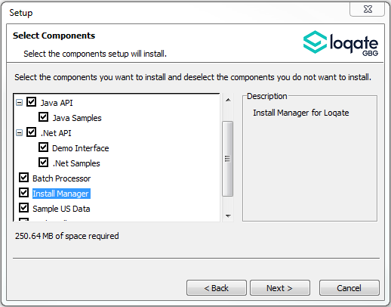

Standard GBG Loqate Installation (Multi-threaded)
- Download the contents of the 2019Q4.0/AppInstaller directory.
- Check the MD5 checksums to ensure that the download has been successful.
- Run the relevant Loqate Local API installer. Please note you may need to add execute privileges to the relevant installer when using Linux. Make sure the option “Install Manager” is selected for installation.
- Execute the Install Manager script (InstallManager.bat on Windows and InstallManager.sh on other Linux/Unix platforms) and install the data. For further details, please review the 2019Q4.0 Installation Instructions document.
- Run the relevant Global Knowledge Repository installer. Please note you may need to add execute privileges when using Linux.

Single-threaded GBG Loqate Installation
- Download the contents of the 2019Q4.0/STAppInstaller directory.
- Check the MD5 checksums to ensure that the download has been successful.
- Run the relevant Loqate Local API installer. Please note you may need to add execute privileges to the relevant installer when using Linux. Make sure the option “Install Manager” is selected for installation.
- Execute the InstallManager script (InstallManager.bat on Windows and InstallManager.sh on other Linux/Unix platforms) and install the data. For further details, please review the 2019Q4.0 Installation Instructions document.
- Run the relevant Global Knowledge Repository installer. Please note you may need to add execute privileges when using Linux.

SFTP Server Contents
On the GBG Loqate SFTP server, you will find the following items:
- AppInstaller: The folder which contains the Loqate Local API installer
- loqate_installer_aix: The AIX Loqate Local API installer
- loqate_installer_hpux: The HP-UX Loqate Local API installer
- loqate_installer_solaris_x86: The Solaris x86 Loqate Local API installer
- loqate_installer_sparc: The Solaris SPARC Loqate Local API installer
- loqate_installer_x86: The Linux 32-bit Loqate Local API installer
- loqate_installer_x86-cpp5: The Linux 32-bit C++ v5 Local API Loqate library installer
- loqate_installer_x86_64: The Linux 64-bit Loqate Local API installer
- setup.exe: The Windows 32-bit Loqate Local API installer
- setup_x64.exe: The Windows 64-bit Loqate Local API installer
- AppInstaller-md5.txt : Contains the checksums of the files in the folder
- STAppInstaller: The folder which contains the Loqate Local API installer for single-threaded libraries
- loqate_installer_aix: The AIX Loqate Local API installer
- loqate_installer_hpux: The HP-UX Loqate Local API installer
- loqate_installer_solaris_x86: The Solaris x86 Loqate Local API installer
- loqate_installer_sparc: The Solaris SPARC Loqate Local API installer
- loqate_installer_x86: The Linux 32-bit Loqate Local API installer
- loqate_installer_x86-cpp5: The Linux 32-bit C++ v5 Local API Loqate library installer
- loqate_installer_x86_64: The Linux 64-bit Loqate Local API installer
- AppInstaller-md5.txt : Contains the checksums of the files in the folder
- STAppInstaller-md5.txt : Contains the checksums of the files in the folder
- OSGi: The folder which contains the OSGi bundle for the Loqate Local API
- loqate-osgi-1.0.0.0.jar: The OSGi bundle for Loqate Local API installer
- osgi-md5.txt: Contains the checksums of the files in the folder
- Rawfiles: The folder which contains the Loqate Local API files in the following subfolders
- aix: The AIX Loqate Local API library files
- hp-ux: The HP-UX Loqate Local API library files
- solaris_x86: The Solaris x86 Loqate Local API library files
- sparc: The Solaris SPARC Loqate Local API library files
- linux32: The Linux 32-bit Loqate Local API library files
- linux32-cpp5: The Linux 32-bit C++ v5 Loqate Local API library files
- linux64: The Linux 64-bit Loqate Local API library files
- win64: The Windows 32-bit Loqate Local API library files
- win32: The Windows 64-bit Loqate Local API library files

Need Help?
Many answers to your questions may be found in our support pages. For additional information, please visit the support site. Below are a list of useful links.

- Support Home Page: http://support.loqate.com
- Getting Started: https://support.loqate.com/getting-started/
- Local APIs: http://support.loqate.com/support/local-apis/
- Field Descriptions: http://support.loqate.com/support/fielddescrip/
- Server and Process Options: http://support.loqate.com/support/options/
- System Requirements: http://support.loqate.com/system-requirements/
If you have any general questions, issues, or enhancement request you’d like to share with us, please contact our support team at: support@loqate.com.

