Loqate, A GBG Solution Release Notes
2019Q2.0 Major Release
Table of Contents
Case Resolutions 3
Local API Updates 3
New Features 3
Certification Updates 4
Certification Expiration Dates 5
Country Improvement Project (PDH) 6
Guernsey 6
Isle of Man 8
Jersey 10
Korea 12
Lithuania 14
Malaysia 16
Peru 17
Phillipines 18
Portugal 19
Spain 21
Uruguay 24
Countries with Format Changes 26
Canada 26
New Zealand 27
Knowledge Base & Reference Data Updates 28
Installation Instructions 36
Standard GBG Loqate Installation (Multi-threaded) 36
Single-threaded GBG Loqate Installation 36
SFTP Server Contents 37
Need Help? 38

Case Resolutions
Please visit http://support.loqate.com/2019q2-0-resolved-cases/ for a list of cases resolved in this release.

If you would like more details on any of the solved cases listed, please contact support@loqate.com for further information.

Local API Updates
We have further removed the chances of seeing the invalid floating point operation. If a user chooses to report an invalid floating point operation, (_EM_INVALID bit), via the floating point control word, ( _controlfp), the exception will no longer appear.

New Features
The GeocodeRefinement tool is a new option available with the 2019Q2.0 release. This option is used to create stricter matching rules to identify the geocode. The default value is set to true.

The Geocode tool uses a new candidate ranking system. This new system will no longer produce false positives and will also be less tolerant to poor country data quality. Please note, you may see several geocode differences with this release, this is to be expected.

The new candidate ranking system requires the geographical hierarchy to be completed before a geocode can be shortlisted. For example, the thoroughfare level geocode returned must be matched by both administrative area and postal code (or locality) level.

In cases where a thoroughfare includes only a match on administrative area and locality, but not matching via the postalcode; these candidates will not be shortlisted as the geographical hierarchy is consider incomplete.

A candidate, in this case, is identified as a particular combination. The below are possible combinations:
- Best candidates: has Level-1 (AdminArea), Level-2 (Locality, PostalCode), Level-3 (Thoroughfare) matches
- Current candidates: has Level-2 (Locality), Level-3 (Thoroughfare) matches
- Another candidate: has Level-1 (AdminArea), Level-3 (Thoroughfare) matches
When GeocodeRefinement = True
- If there is a level-1 and a level-3 matched, but not matching on level-2 input; then the geocode will not be outputted.
- If there are no matches found in level-1, we will proceed if level-1 alias deduction of current candidates against the best candidates (by getting 6 uniformly distribute samples across the two). If all 6 samples show the same (i.e. in terms of aliases) the geocode will be accepted, otherwise we will not accept the geocode.

When GeocodeRefinement = False
- The engine will not output a geocode if and only if Verify has a non-empty level-2 result.
- If there are no matches found in level-1, the geocode will be accepted.

Certification Updates
IMPORTANT - CASS Users:

- New platform available:
CASS windows64 will now be available with the 2019Q2.0 release. Please follow the Install Manager instructions found here and select CASS Library (Windows 64) and USA Verify Dataset CASS to install Windows64.

- CASS Expiration Dates:
CASS is currently set to expire on July 31st, 2019. USPS has extended Cycle N and the new expiry date is July 31st, 2020. Please upgrade to the 2019Q2.0 API and CASS libraries to continue your CASS usage, otherwise CASS will expire on July 31st, 2019.

- Linux64 Platform Users:
Due to a crash in CASS on the Linux platform, USPS has provided a new API. In order for the change to take effect, you will need to update both the Loqate API and the CASS library.

Linux64 Library Update:
USPS recently updated the libraries to be a single dynamic library. This platform previously had 5 libraries and now changed to a single dynamic library. Please see figure 1 below for the list of valid libraries.

For continue use of CASS on the Linux platform, please update to the 2019Q2.0 release of Loqate API and CASS library.

- CASS Windows32 version:
This platform continues to be 5 dependent dynamic libraries and is compatible with 2019Q2.0 and older release. Please see figure 1 below for the list of valid libraries.
Figure 1.
Platform | Current Libraries (2019Q1.1 and older) | New Libraries (2019Q2.0 and newer) | Compatible with Loqate API Version
Linux64 | libabbrst.so.1 | libz4lnx64.so | 2019Q2.0
 | libdpv.so.9
 | libkeymgr.so.3
 | libstelnk.so.2
 | libz4lnx64.so
Win32 | abbrst1.dll | No change | 2019Q2.0
 | dpv9.dll |  | + older versions
 | keymgr3.dll
 | stelnk2.dll
 | zip4_w32.dll
Win64 | None | zip4_w64.dll | New Platform - 2019Q2.0

Certification Expiration Dates
If you have purchased either the CASS (USA) or AMAS (Australia) certified products, please be aware that the datasets have expiration dates set by the respective postal authorities. Please ensure that you have the latest library and data installed to avoid loss of service through these products.
Please check Install Manager for the latest versions of AMAS and CASS.
 | Loqate Release Date | Certification Expiry Date*
AMAS Data | 2019-03-06 | 2019-06-30
CASS Data | 2019-04-17 | 2019-07-29
*Certification Expiry Date is different from Loqate license key expiry date. The earliest expiry date will apply.

For more information on expiry date checking for CASS and AMAS, please refer “Usage expiration” section in https://support.loqate.com/documentation/local-apis/cass-overview-2/ and https://support.loqate.com/address-matching-approval-system-amas/

Country Improvement Project (PDH)
The following section will display the changes made during the country improvement process. For this quarter we’ve released improved datasets for 11 countries.

Guernsey
Country Information | Description
ISO 2 | GG
ISO 3 | GGY
Address Format | Organization  PostBox  SubBuilding SubBuildingFloor Building  Premise Thoroughfare  DoubleDependentLocality  DependentLocality  Locality  PostalCode
PDH | Yes (2019Q2.0)
New Source | No

Files Used | Pre-PDH | Post-PDH
Knowledge Base Files | Country.lfs  Context.lfs  Format.lfs | Country.lfs  Context.lfs  Format.lfs
Reference Data | rd_GG_geo.lfs  rd_GG_geo_rg.lfs  rd_GG_vfy_ai.lfs  rd_GG_vfy.lfs | rd_GG_ggg.lfs  rd_GG_ggg_rg.lfs  rd_GG_vfy_ai.lfs  rd_GG_vfy.lfs

Before PDH | After PDH
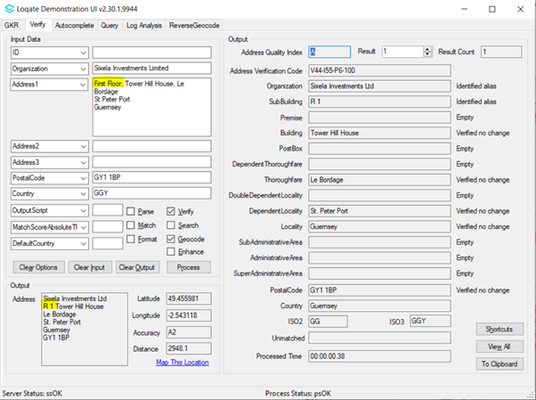  2019Q1.1 – Incorrect SubBuildingFloor returned. | 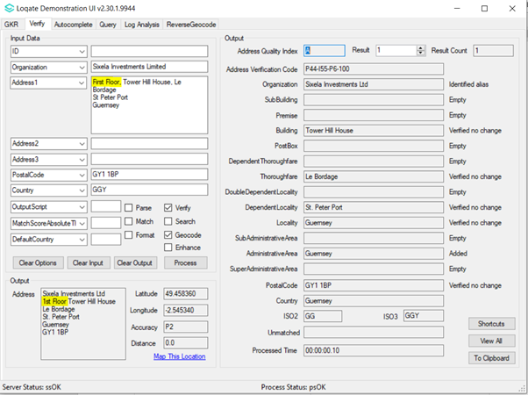  2019Q2.0 – Correct SubBuildingFloor returned.
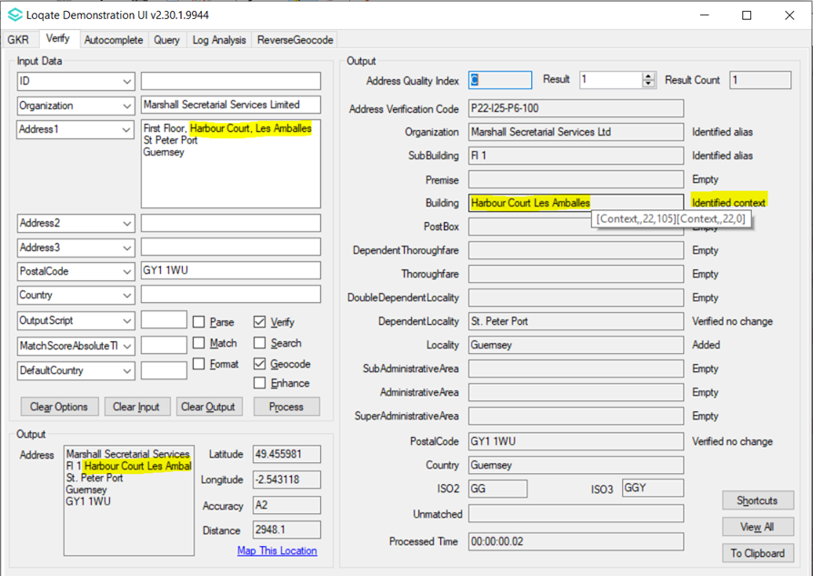  2019Q1.1 – Incorrect parsing of Building and Thoroughfare. | 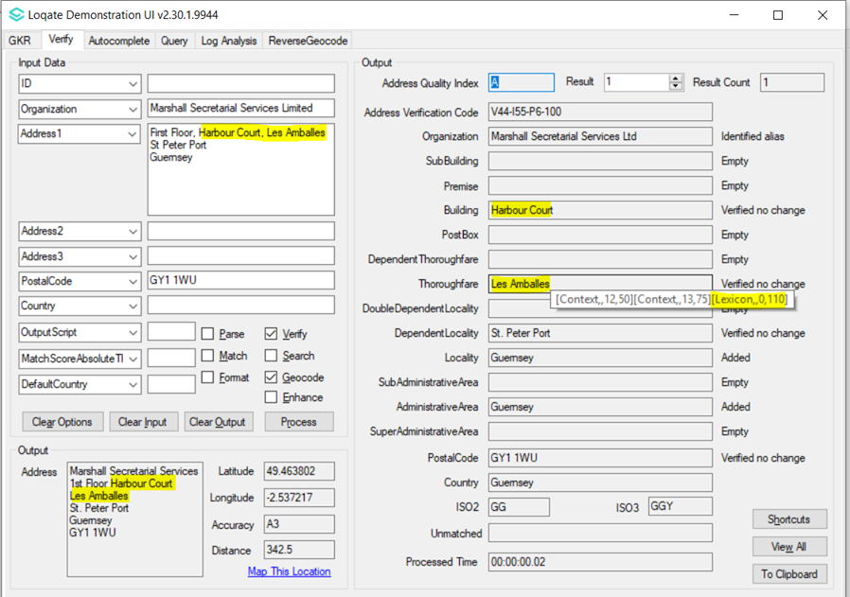  2019Q2.0 – Correct parsing of Building and Thoroughfare.

Isle of Man
Country Information | Description
ISO 2 | IM
ISO 3 | IMN
Address Format | Organization  PostBox  SubBuilding SubBuildingFloor Building  Premise Thoroughfare  DoubleDependentLocality  DependentLocality  Locality  PostalCode
PDH | Yes (2019Q2.0)
New Source | No

Files Used | Pre-PDH | Post-PDH
Knowledge Base Files | Country.lfs  Context.lfs  Format.lfs | Country.lfs  Context.lfs  Format.lfs
Reference Data | rd_IM_geo.lfs  rd_IM_geo_rg.lfs  rd_IM_vfy_ai.lfs  rd_IM_vfy.lfs | rd_IM_ggg.lfs  rd_IM_ggg_rg.lfs  rd_IM_vfy_ai.lfs  rd_IM_vfy.lfs

Pre-PDH | Post-PDH
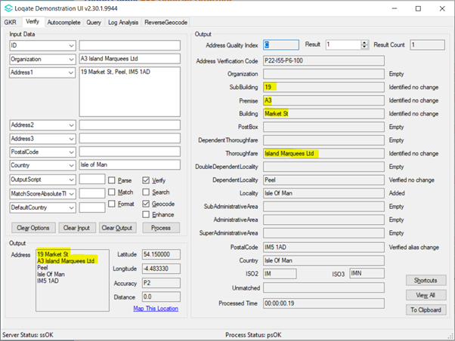  2019Q1.1 – Incorrect parsing of Organization, Premise and Thoroughfare. | 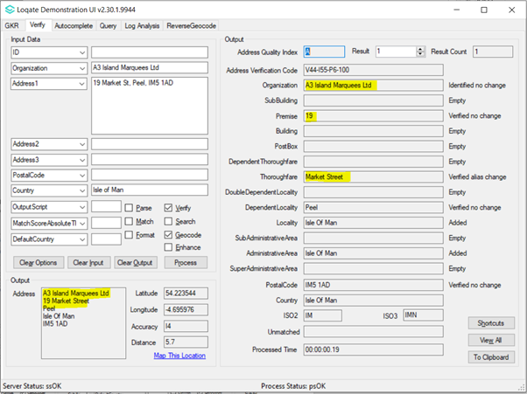  2019Q2.0 – Correct parsing of Organization, Premise and Thoroughfare.
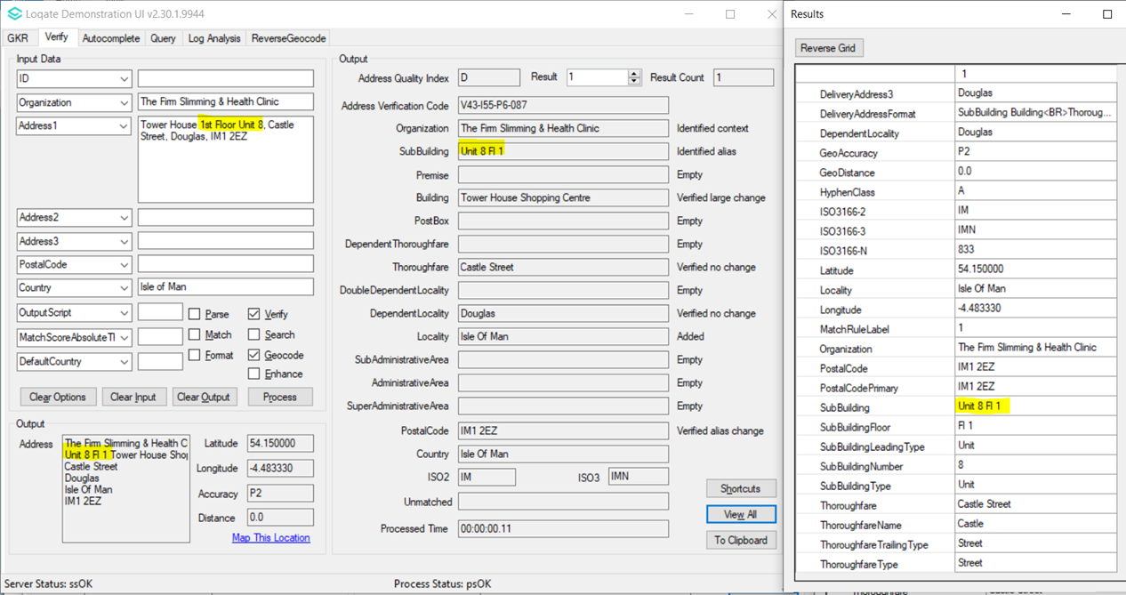  2019Q1.1 – Both SubBuildingFloor and SubBuilding parsed into single SubBuilding field. | 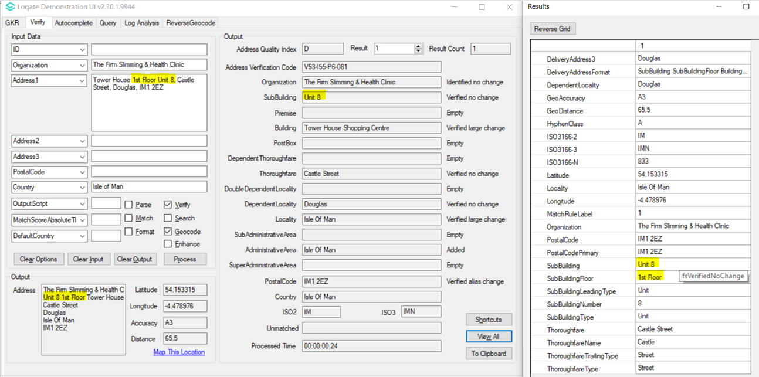  2019Q2.0 – SubBuildingFloor and SubBuilding parsed to two separate fields, V5 returned.

Jersey
Country Information | Description
ISO 2 | JE
ISO 3 | JEY
Address Format | Organization  PostBox  SubBuilding Building  Premise DependentThoroughfare  Thoroughfare  DoubleDependentLocality  DependentLocality  Locality  PostalCode
PDH | Yes (2019Q2.0)
New Source | No

Files Used | Pre-PDH | Post-PDH
Knowledge Base Files | Country.lfs  Context.lfs  Format.lfs | Country.lfs  Context.lfs  Format.lfs
Reference Data | rd_JE_geo.lfs  rd_JE_geo_rg.lfs  rd_JE_vfy_ai.lfs  rd_JE_vfy.lfs | rd_JE_ggg.lfs  rd_JE_ggg_rg.lfs  rd_JE_vfy_ai.lfs  rd_JE_vfy.lfs

Pre-PDH | Post-PDH
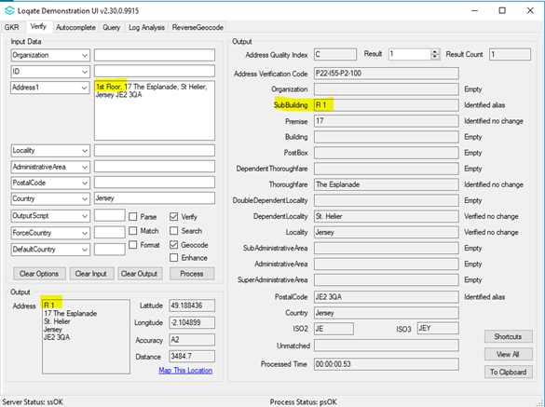  2019Q1.1 - SubBuildingFloor parsed to SubBuilding field and identified. | 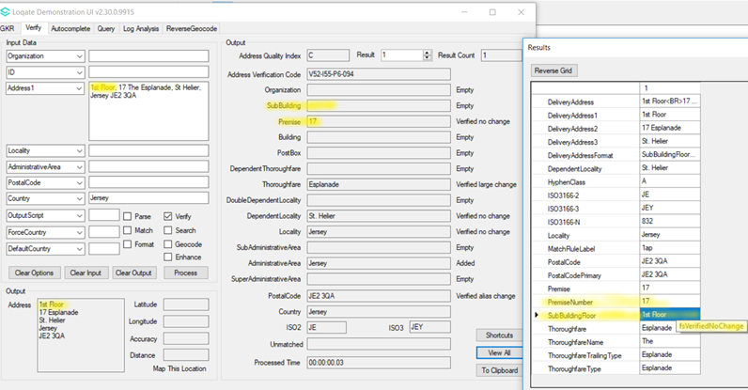  2019Q2.0 - SubBuildingFloor parsed to SubBuildingFloor field and verified no change. The format of SubBuildingFloor is corrected.
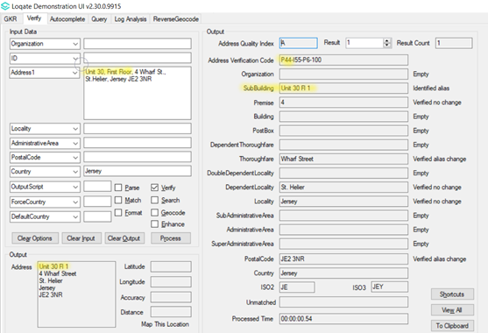  2019Q1.1 - Both SubBuilding and SubBuilding Floor parsed into single SubBuilding field. | 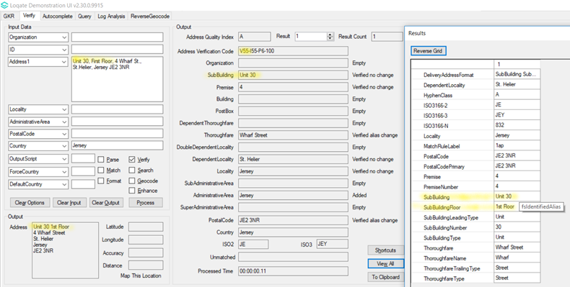  2019Q2.0 - SubBuilding and SubBuilding Floor parsed to two separate fields, V5 returned.

Korea

Country Information | Description
ISO 2 | KR
ISO 3 | KOR
Address Format (Latin) | Organization PostBox  Building SubBuilding  Premise DependentThoroughfare Thoroughfare  DoubleDependentLocality DependentLocality  Locality  AdministrativeArea PostalCode
Address Format (Native) | PostalCode AdministrativeArea  Locality Thoroughfare DependentThoroughfare  Premise SubBuilding (DependentLocality Building) Postbox  Organization
PDH | Yes (2019Q2.0)
New Source | No

Files Used: | Pre-PDH | Post-PDH
Knowledge Base Files | Country.lfs  Context.lfs  Format.lfs | Country.lfs  Context.lfs  Format.lfs
Reference Data | rd_KR_geo.lfs  rd_KR_vfy_ai.lfs  rd_KR_vfy_f.lfs  rd_KR_vfy.lfs  rd_KR_vfy_r.lfs | rd_KR_ggg.lfs  rd_KR_ggg_r1.lfs  rd_KR_ggg_rg.lfs  rd_KR_ggg_r.lfs  rd_KR_vfy_ai.lfs  rd_KR_vfy.lfs

Pre-PDH | Post-PDH
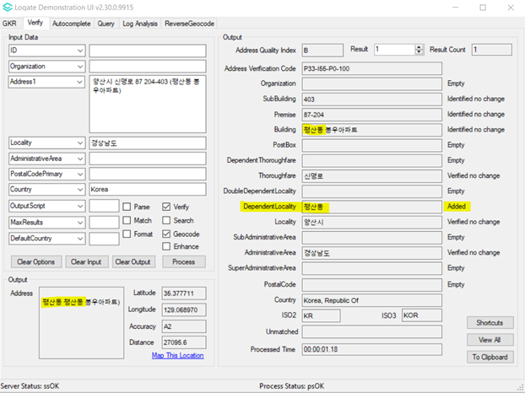  2019Q1.0 - DependentLocality parsed to Building field and duplicate DependentLocality appeared in output address. | 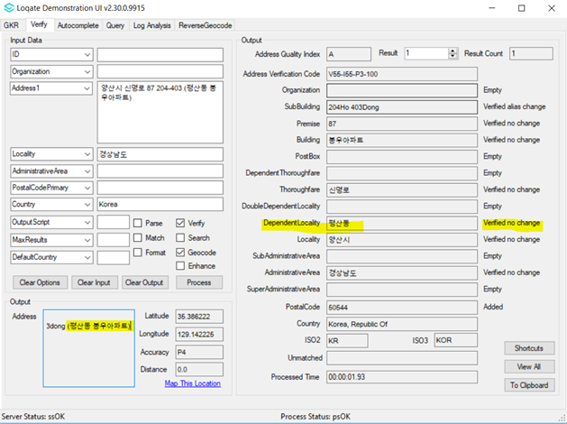  2019Q2.0 - DependentLocality parsed correctly and duplicate no longer appear in output address.
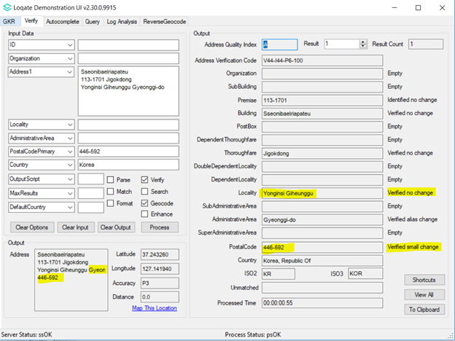  2019Q1.0 - Old postcode is outputted, locality name in the incorrect order (-si, followed by -gu) | 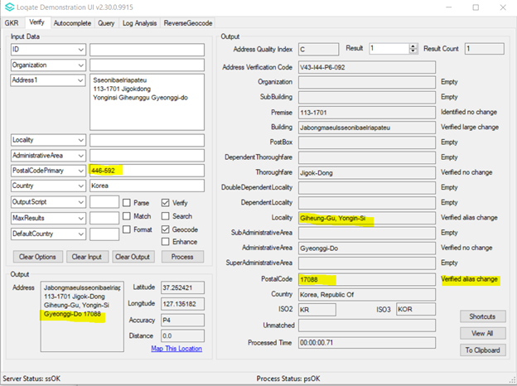  2019Q2.0 - Input old postcode is verified alias change and output new postcode, locality name in correct order (-gu, followed by -si)

Lithuania
Country Information | Description
ISO 2 | LT
ISO 3 | LTU
Address Format  (Not in centre of municipality) | Organization  PostBox  Building  Thoroughfare Premise-SubBuilding  DependentLocality  Locality  PostalCode SubAdministrativeArea
Address Format  (In centre of municipality) | Organization  PostBox  Building  Thoroughfare Premise-SubBuilding  DependentLocality  PostalCode Locality
PDH | Yes (2019Q2.0)
New Source | No

Files Used | Pre-PDH | Post-PDH
Knowledge Base Files | Country.lfs  Context.lfs  Format.lfs | Country.lfs  Context.lfs  Format.lfs
Reference Data | rd_LT.lfs  rd_LT_ai.lfs  rd_LT_rg.lfs  rd_LT_geop.lfs  rd_LT_geop_rg.lfs | rd_LT_vfy.lfs  rd_LT_vfy_ai.lfs  rd_LT_ggg.lfs  rd_LT_ggg_rg.lfs

Pre-PDH | Post-PDH
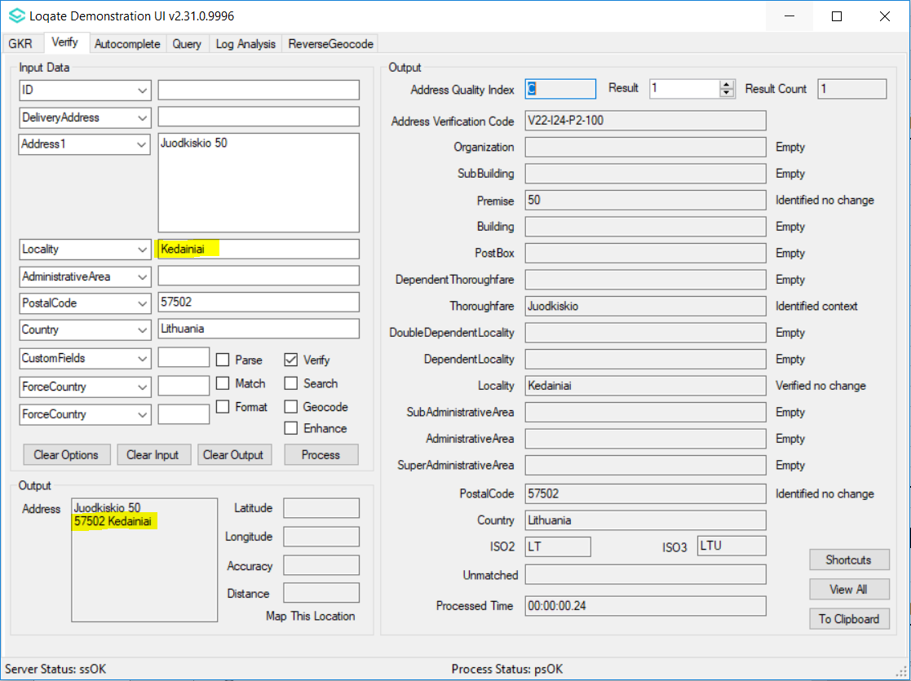  2019Q1.0 - Before data realignment and format changes, Locality is returned instead of SubAdministrativeArea in the address output. | 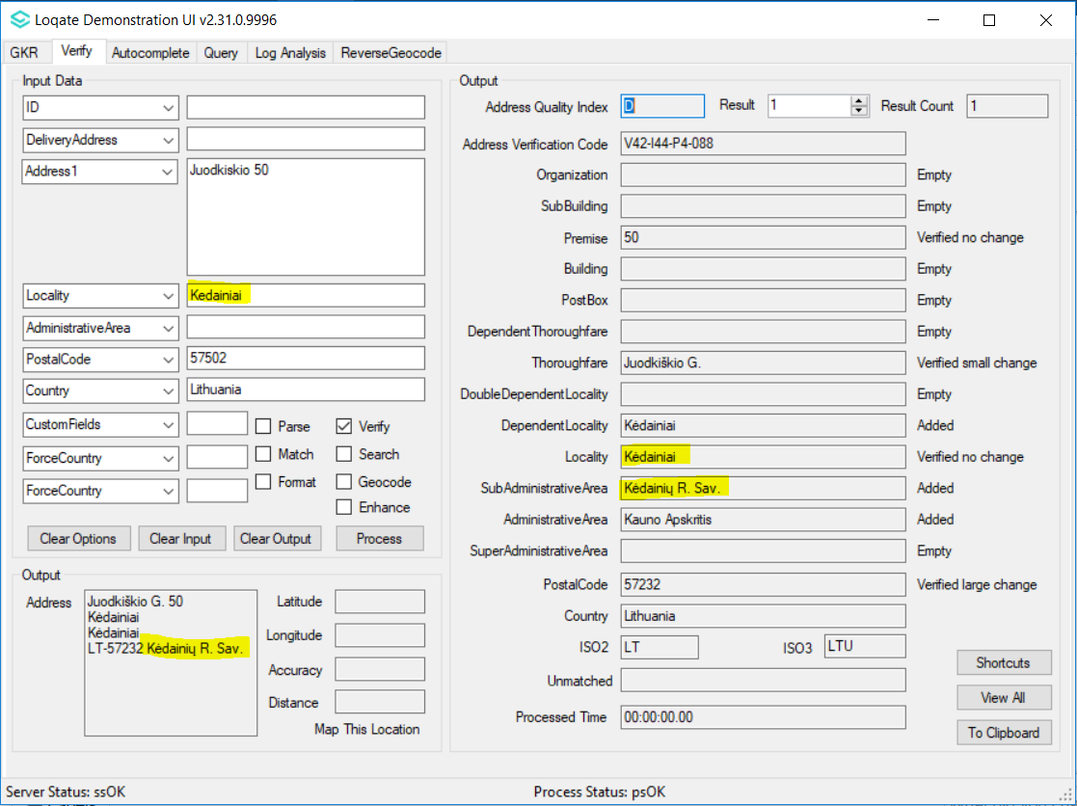  2019Q2.0 - Changes in alignment and address format. SubAdministrativeArea will be outputted in the address format except for Vilnius city. 'LT-' is placed before the postal codes in new address format.
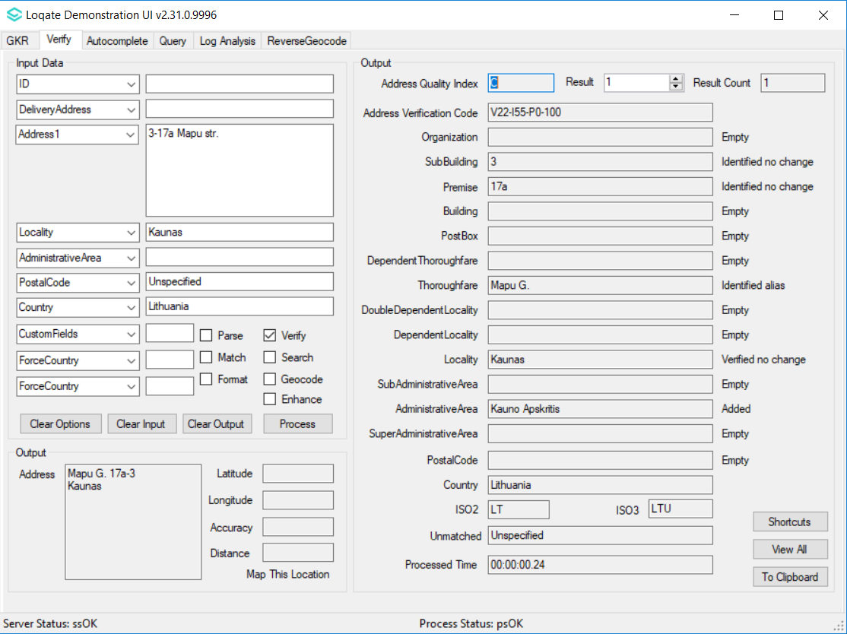  2019Q1.0 - Part of thoroughfare name incorrectly parsed into premise field. | 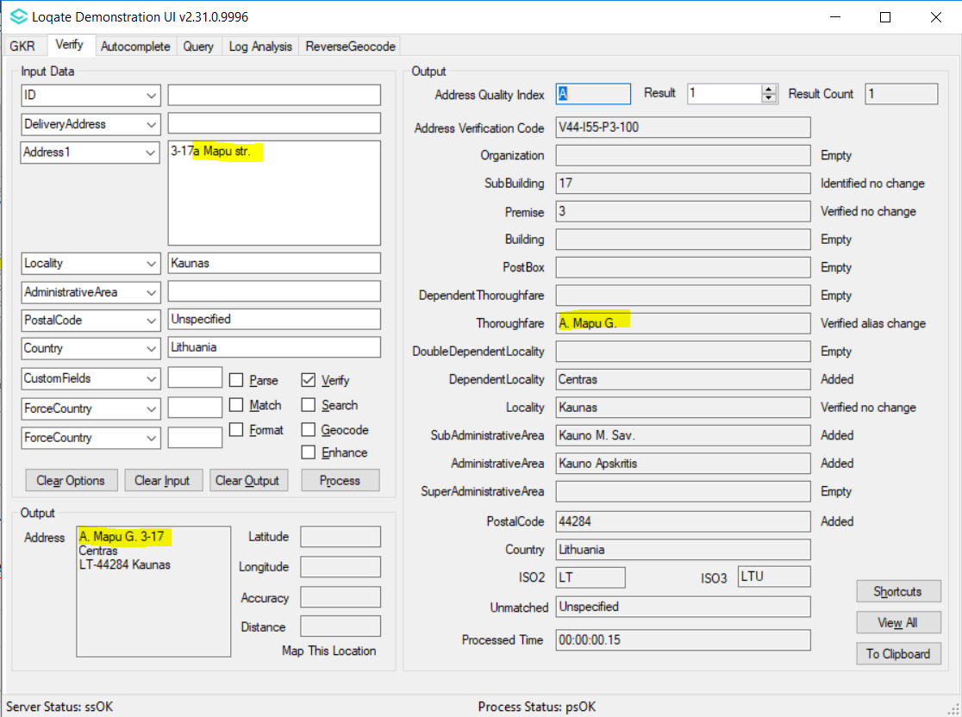  2019Q2.0 - Thoroughfare name is parsed and verified correctly.

Malaysia
Country Information | Description
ISO 2 | MY
ISO 3 | MYS
Address Format | Organization  PostBox  SubBuilding Building  Premise Thoroughfare  DependentThoroughfare  DoubleDependentLocality  DependentLocality  PostalCode Locality AdministrativeArea
PDH | Yes (2019Q2.0)
New Source | No

Files Used | Pre-PDH | Post-PDH
Knowledge Base Files | Country.lfs  Context.lfs  Format.lfs | Country.lfs  Context.lfs  Format.lfs
Reference Data | rd_MY.lfs  rd_MY_ai.lfs  rd_MY_rg.lfs  rd_MY_geop.lfs  rd_MY_geop_rg.lfs | rd_MY_vfy.lfs  rd_MY_vfy_ai.lfs  rd_MY_ggg.lfs  rd_MY_ggg_rg.lfs

Pre-PDH | Post-PDH
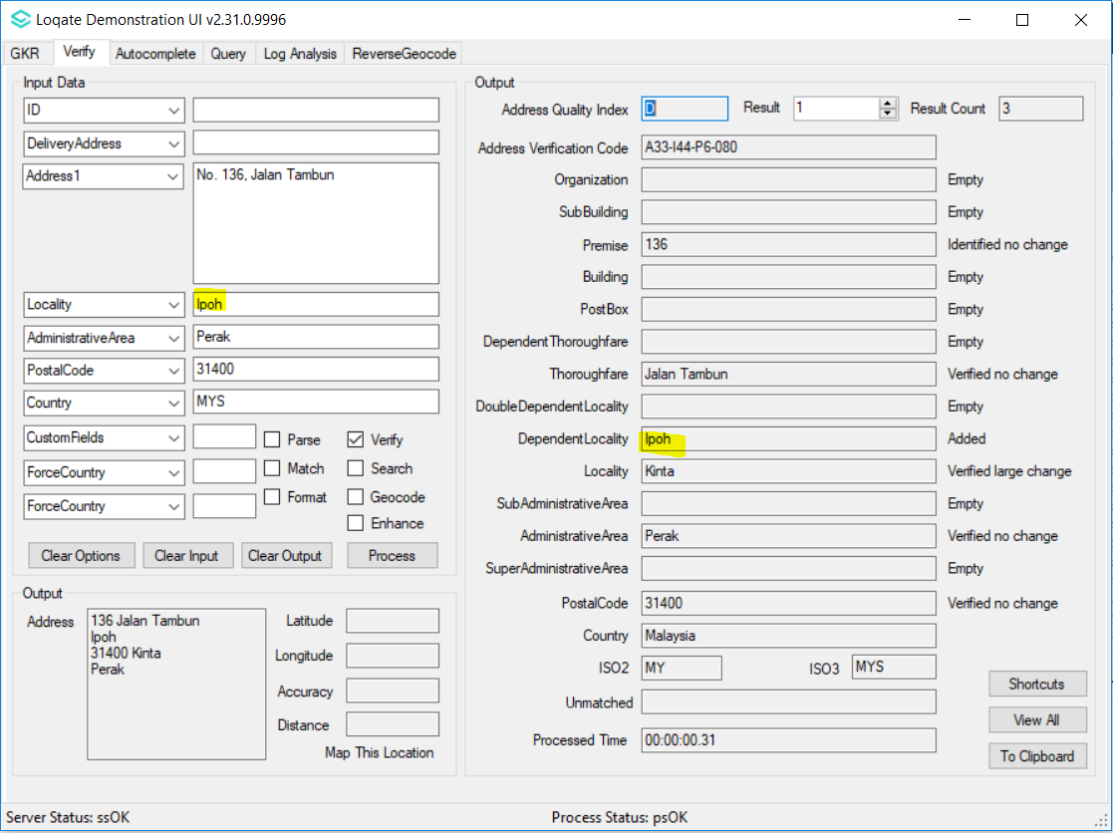  2019Q1.0 - Incorrect data alignment, Ipoh is in DependentLocality level. | 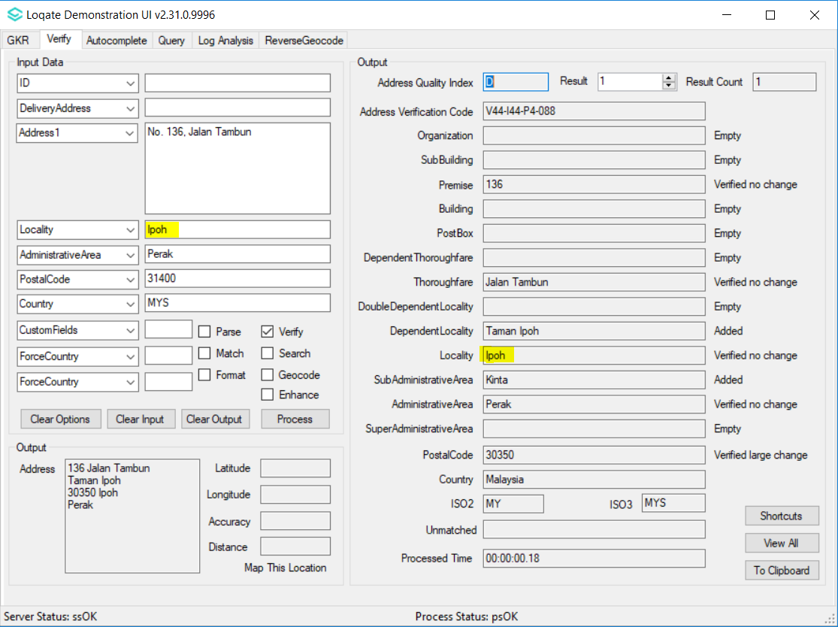  2019Q2.0 - After data realignment, Ipoh is in Locality level.

Peru
Country Information | Description
ISO 2 | PE
ISO 3 | PER
Address Format | Organization  PostBox  Thoroughfare Premise  SubBuilding Building  DependentLocality  Locality PostalCode  AdministrativeArea
PDH | Yes (2019Q2.0)
New Source | No

Files Used | Pre-PDH | Post-PDH
Knowledge Base Files | Country.lfs  Context.lfs  Format.lfs | Country.lfs  Context.lfs  Format.lfs
Reference Data | rd_PE.lfs  rd_PE_ai.lfs  rd_PE_rg.lfs | rd_PE_vfy.lfs  rd_PE_vfy_ai.lfs  rd_PE_ggg.lfs  rd_PE_ggg_rg.lfs

Pre-PDH | Post-PDH
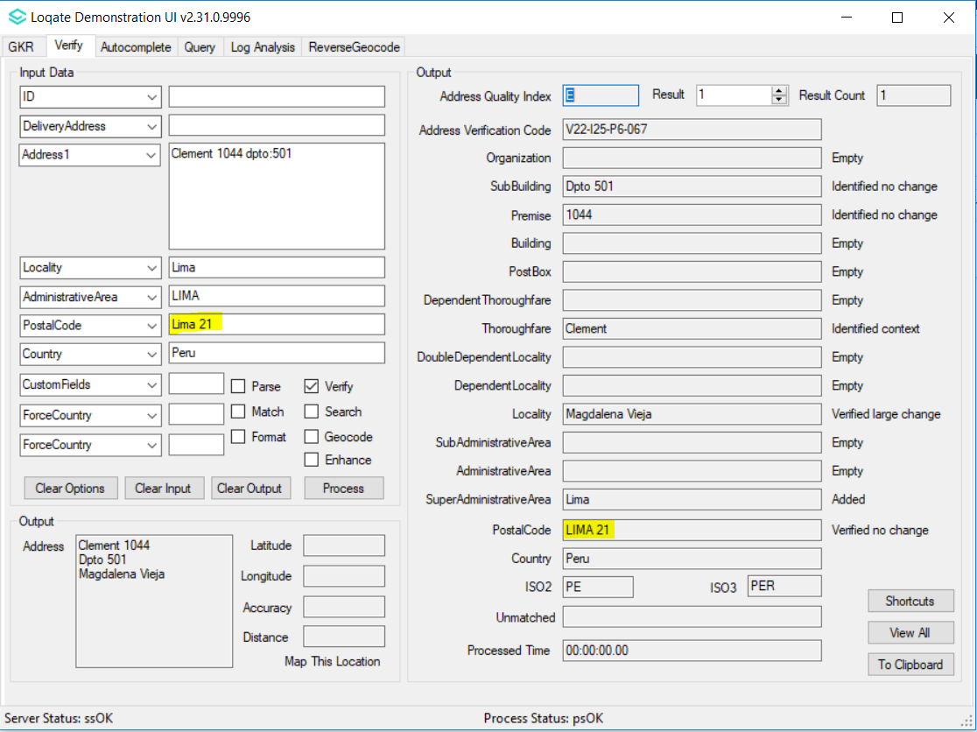  2019Q1.0 - Old postal code (Lima 21) is returned in Postal code field. | 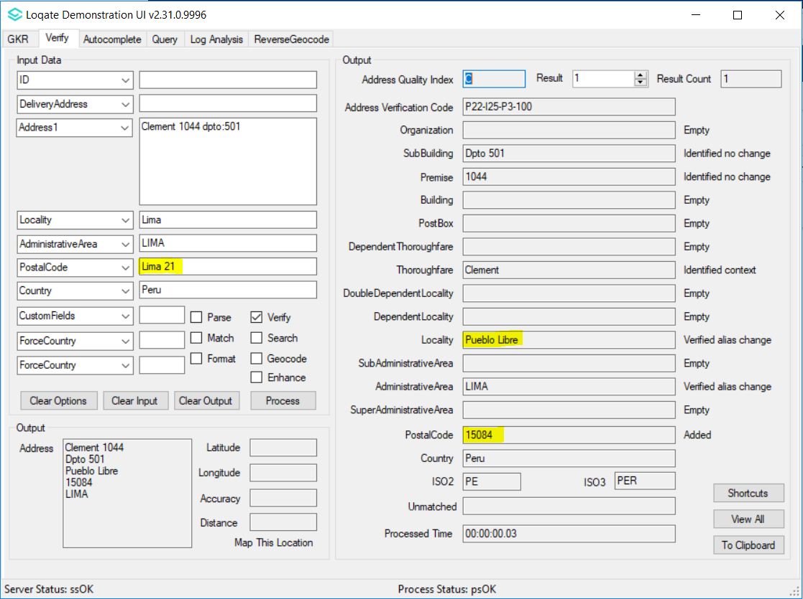  2019Q2.0 - Lima 21 is old postal code for Pueblo Libre district, will be parsed and verified as Locality. The new 5-digits postal code will be added since Peru had started to implement new postal code system.

Phillipines
Country Information | Description
ISO 2 | PH
ISO 3 | PHL
Address Format | Organization  PostBox  SubBuilding Building  Premise Thoroughfare  DependentThoroughfare  DoubleDependentLocality  DependentLocality  Locality  PostalCode AdministrativeArea
PDH | Yes (2019Q2.0)
New Source | No

Files Used | Pre-PDH | Post-PDH
Knowledge Base Files | Country.lfs  Context.lfs  Format.lfs | Country.lfs  Context.lfs  Format.lfs
Reference Data | rd_PH.lfs  rd_PH_rg.lfs  rd_PH_ai.lfs | rd_PH_ggg.lfs  rd_PH_ggg_rg.lfs  rd_PH_vfy_ai.lfs  rd_PH_vfy.lfs

Pre-PDH | Post-PDH
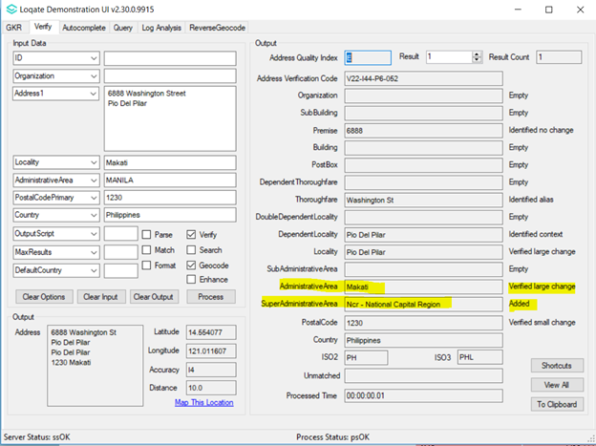  2019Q1.0 - Before data realignment, Makati city is in the Administrative Area level. | 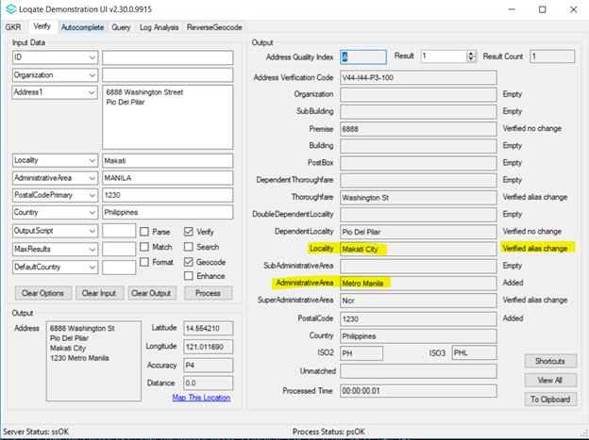  2019Q2.0 - After data realignment, 'Metro Manila' and 'Makati' can be parsed and verified correctly.

Portugal

Country Information | Description
ISO 2 | PT
ISO 3 | PRT
Address Format | Organization  PostBox  Thoroughfare Premise Building SubBuilding  DependentThoroughfare  DoubleDependentLocality  DependentLocality  PostalCode Locality
PDH | Yes (2019Q2.0)
New Source | No

Files Used | Pre-PDH | Post-PDH
Knowledge Base Files | Country.lfs  Context.lfs  Format.lfs | Country.lfs  Context.lfs  Format.lfs
Reference Data | rd_PT.lfs  rd_PT_ai.lfs  rd_PT_geop.lfs  rd_PT_geop_rg.lfs  rd_PT_rg.lfs | rd_PT_ggg.lfs  rd_PT_ggg_rg.lfs  rd_PT_vfy_ai.lfs  rd_PT_vfy.lfs

Pre-PDH | Post-PDH
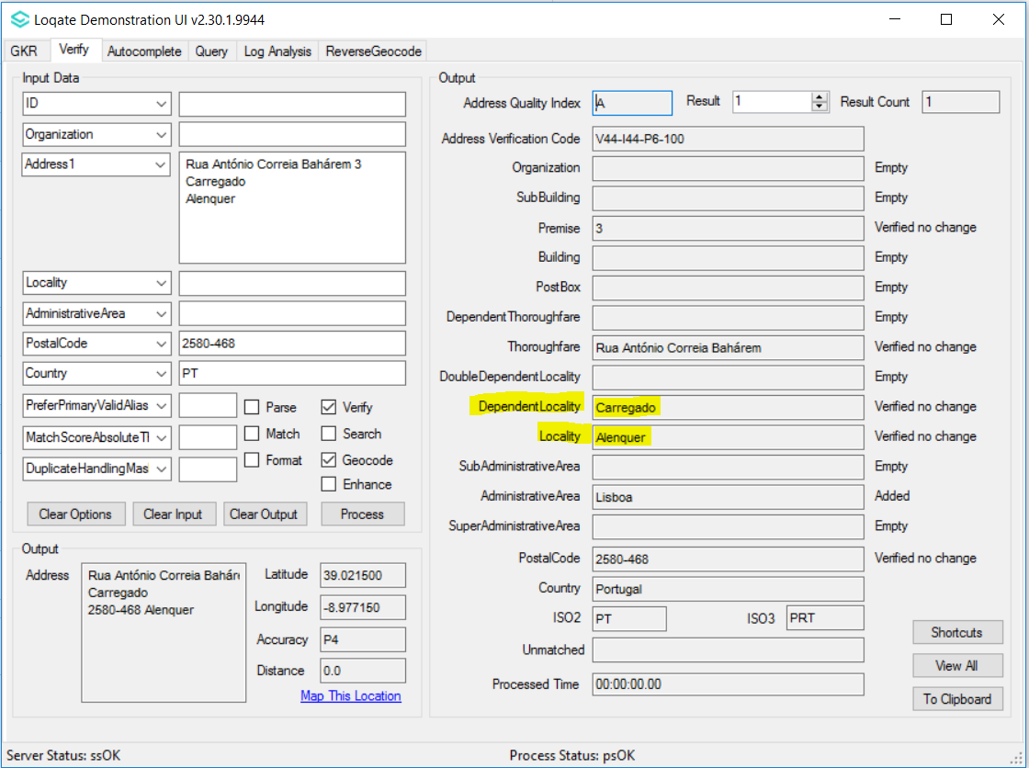  2019Q1.1 - Before data realignment, Alenquer (region) incorrectly verified as Locality. | 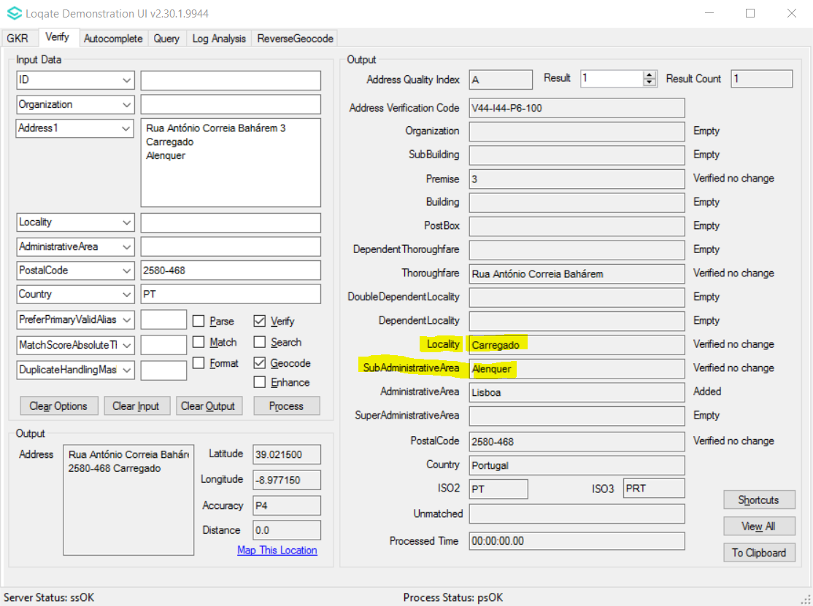  2019Q2.0 - After data realignment, Alenquer (region) verified as SubAdministrativeArea, whereas Locality correctly returned.
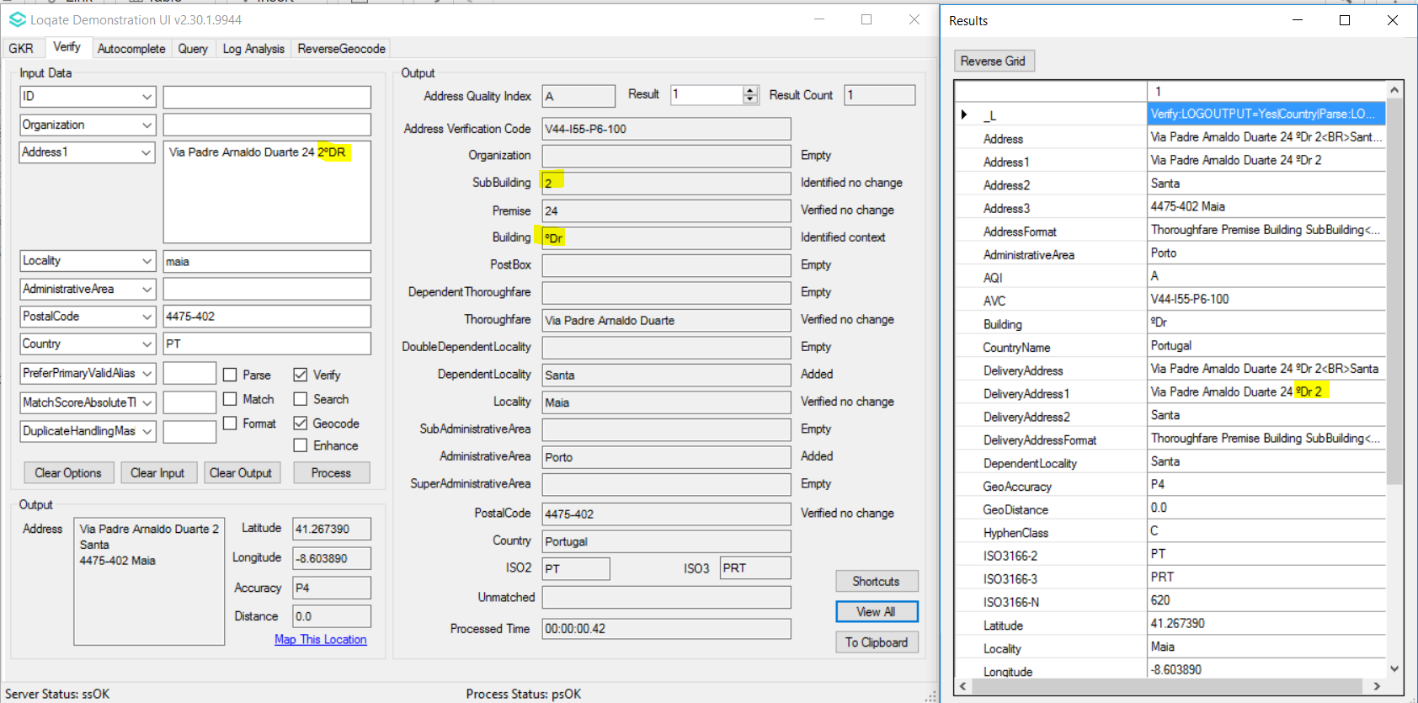  2019Q1.1 - SubBuilding element incorrectly parsed | 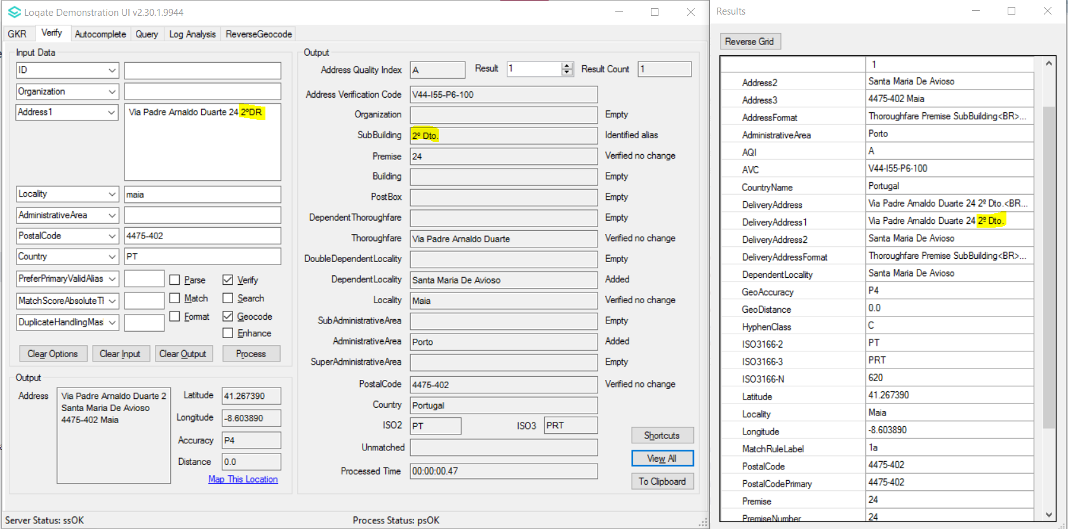  2019Q2.0 - SubBuilding element correctly parsed

Spain
Country Information | Description
ISO 2 | ES
ISO 3 | ESP
Address Format | Organization  Thoroughfare Premise Building SubBuilding  DependentThoroughfare  PostBox  DependentLocality  PostalCode Locality AdministrativeArea
PDH | Yes (2019Q2.0)
New Source | No

Files Used | Pre-PDH | Post-PDH
Knowledge Base Files | Country.lfs  Context.lfs  Format.lfs | Country.lfs  Context.lfs  Format.lfs
Reference Data | rd_ES_geop.lfs  rd_ES_geop_r.lfs  rd_ES_geop_rg.lfs  rd_ES_r.lfs  rd_ES_rg.lfs  rd_ES_ai.lfs  rd_ES.lfs | rd_ES_ggg.lfs  rd_ES_ggg_r1.lfs  rd_ES_ggg_rg.lfs  rd_ES_ggg_r.lfs  rd_ES_vfy_ai.lfs  rd_ES_vfy.lfs

Pre-PDH | Post-PDH
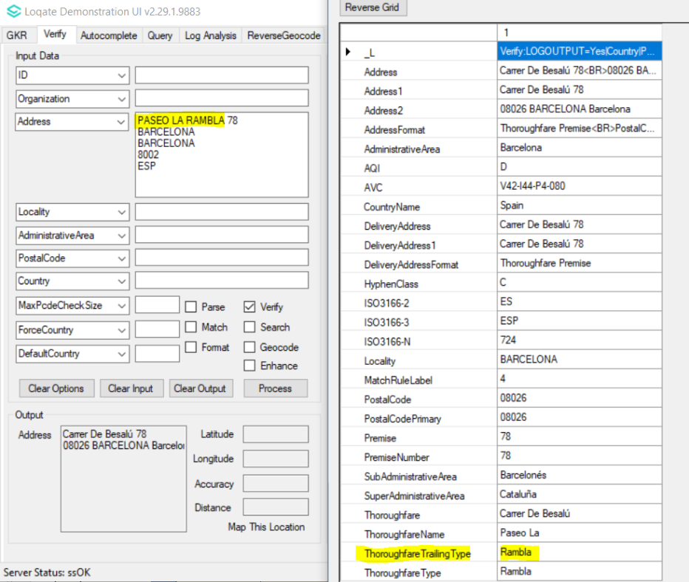  2019Q1.0 - Thoroughfare name is parsed as Thoroughfare Trailing Type | 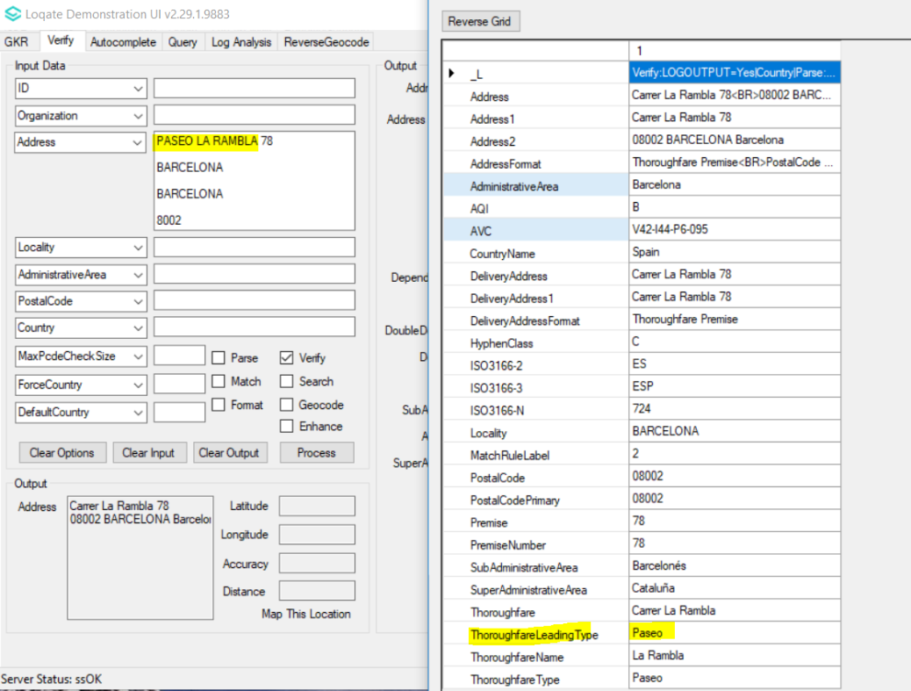  2019Q2.0 - Thoroughfare Leading Type is parsed correctly
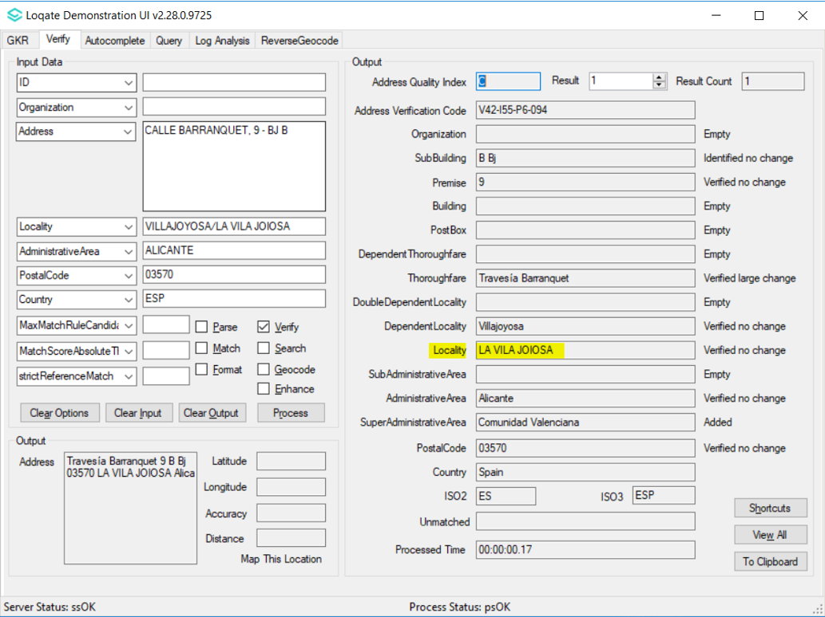  2019Q1.0 – Inconsistent locality returned | 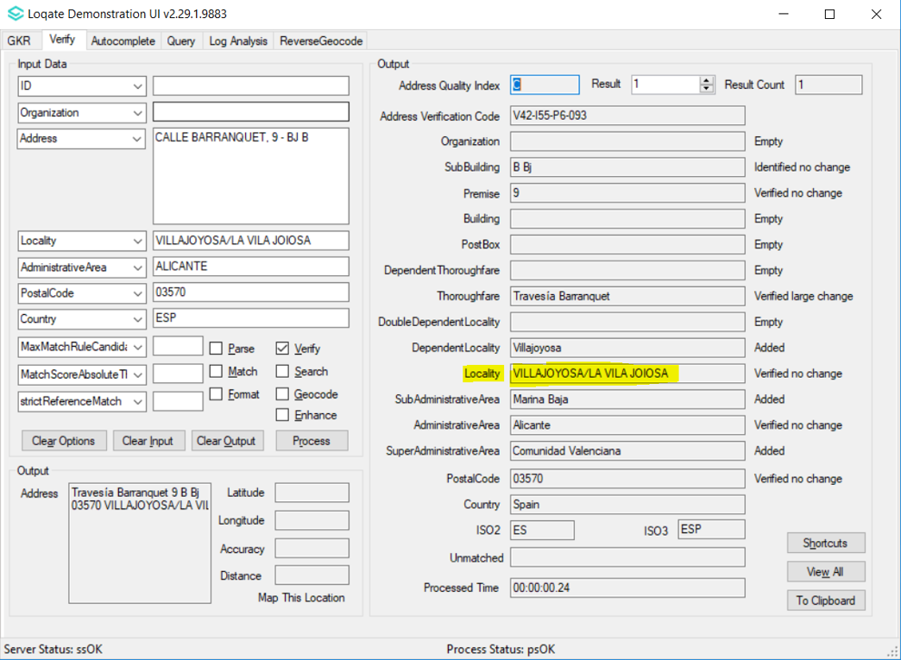  2019Q2.0 – Correct locality returned as in Spanish Post
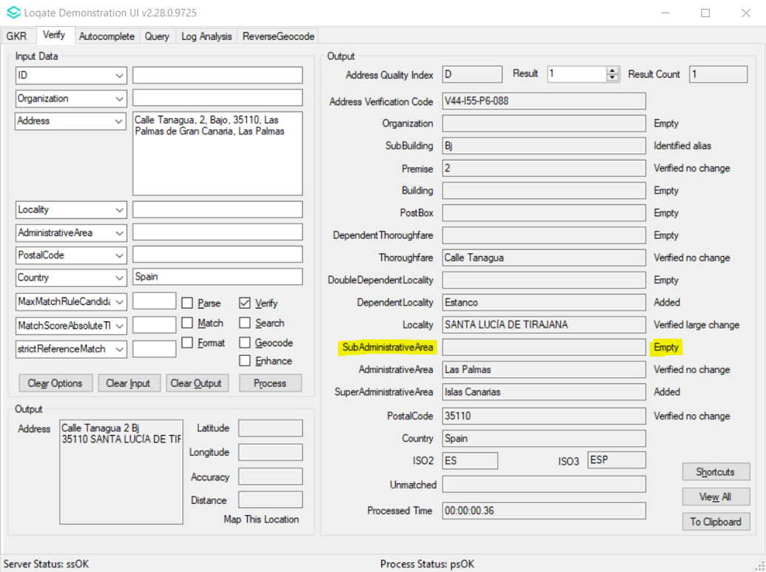  2019Q1.0 – SubAdministrativeArea is empty | 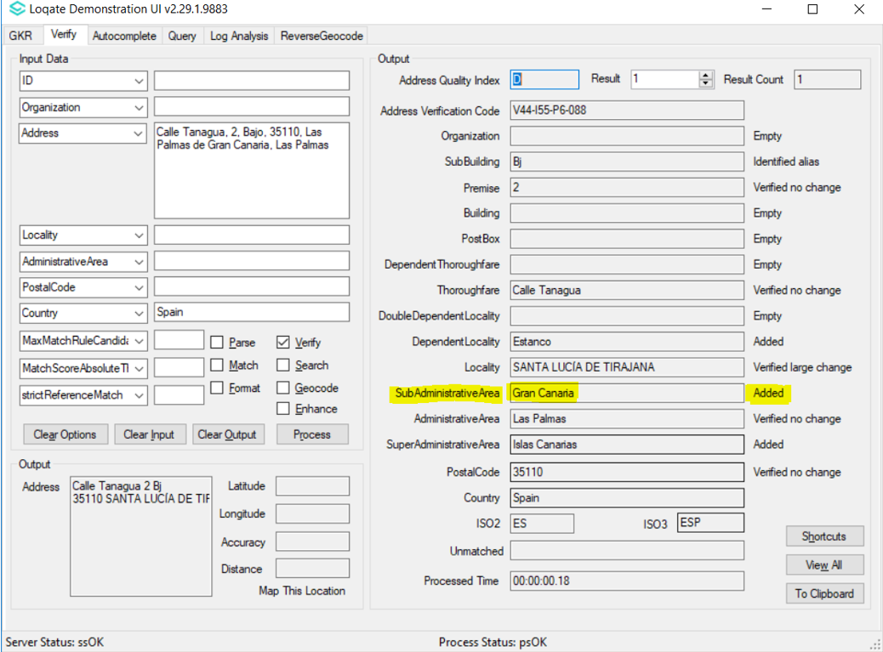  2019Q2.0 – Geography information is added where SubAdministrativeArea is populated

Uruguay
Country Information | Description
ISO 2 | UY
ISO 3 | URY
Address Format | Organization  PostBox  Building SubBuilding  Thoroughfare Premise  DependentThoroughfare  DoubleDependentLocality  DependentLocality  PostalCode Locality
PDH | Yes (2019Q2.0)
New Source | No

Files Used | Pre-PDH | Post-PDH
Knowledge Base Files | Country.lfs  Context.lfs  Format.lfs | Country.lfs  Context.lfs  Format.lfs
Reference Data | rd_UY_ggg.lfs  rd_UY_ggg_rg.lfs  rd_UY_vfy_ai.lfs  rd_UY_vfy.lfs | rd_UY_ggg.lfs  rd_UY_ggg_rg.lfs  rd_UY_vfy_ai.lfs  rd_UY_vfy.lfs

Pre-PDH | Post-PDH
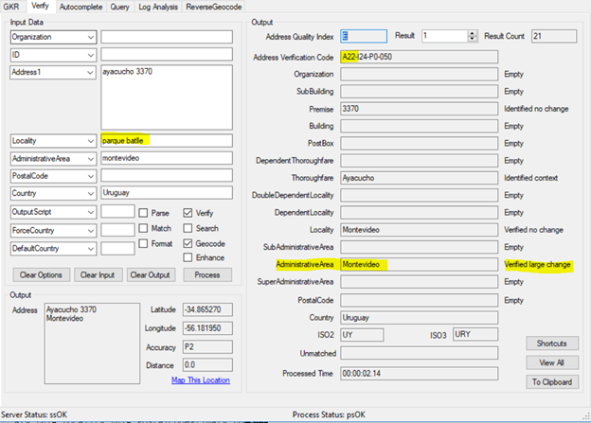  2019Q1.0 - Input locality parsed incorrectly to Administrative Area field. | 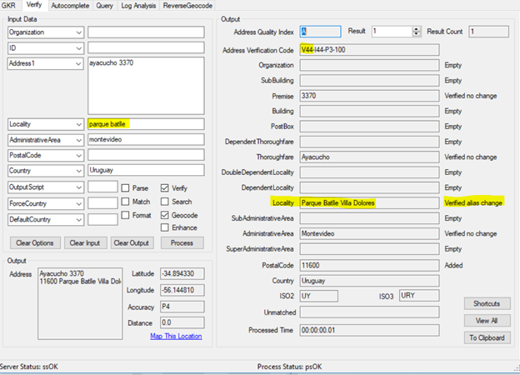  2019Q2.0 - Input locality parsed correctly to locality field and verified alias change.

Countries with Format Changes
Please note, the following countries have Address Format changes.

Canada
Country Information | Description
ISO2 | CA
ISO3 | CAN

Address Format Change
Before 2019Q2.0 | After 2019Q2.0
Building  SubBuilding  PostBox  DeliveryInstallationType DeliveryInstallationQualifierName  Locality AdministrativeArea PostalCode | Building  SubBuilding  PostBox DeliveryInstallationType DeliveryInstallationQualifierName  Locality AdministrativeArea PostalCode
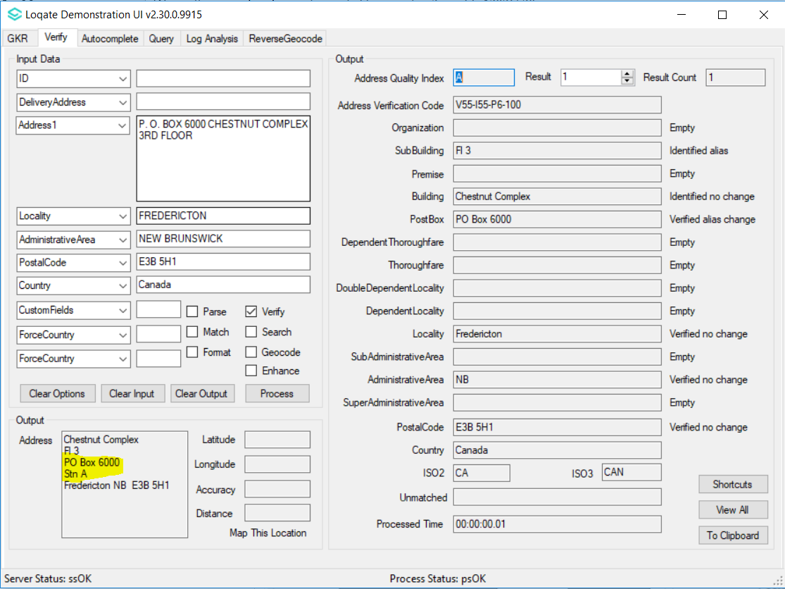  2019Q1.1 - PO Box is placed above Delivery Installation. | 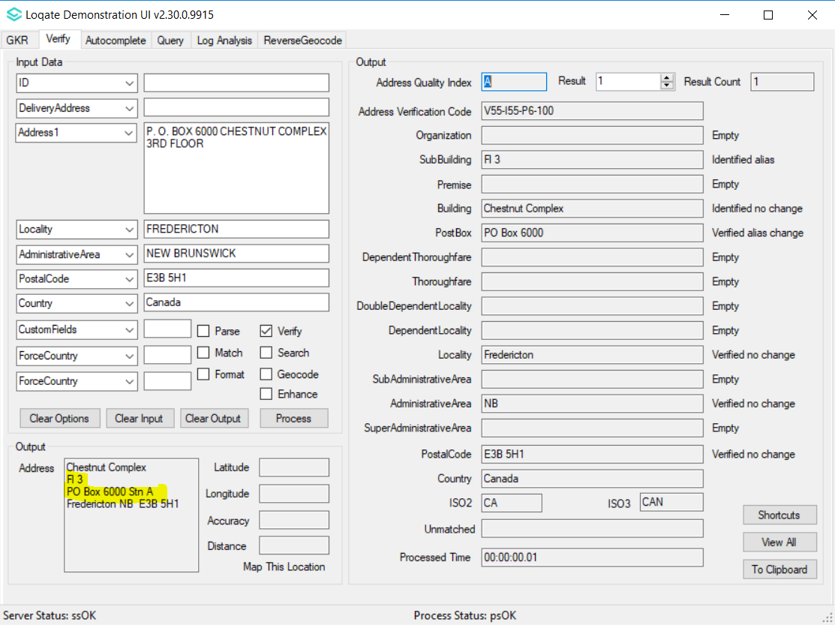  2019Q2.0 - PO Box is placed same line with Delivery Installation.

New Zealand
Country Information | Description
ISO2 | NZ
ISO3 | NZL

Address Format Change
Pre 2019Q2.0 | Post 2019Q2.0
Organization  PostBox  BoxBagLobbyName  SubBuilding Building  Premise Thoroughfare  DependentThoroughfare  Locality PostalCode | Department  Organization  SubBuilding  Building  PostBox  BoxBagLobbyName  Locality PostalCode
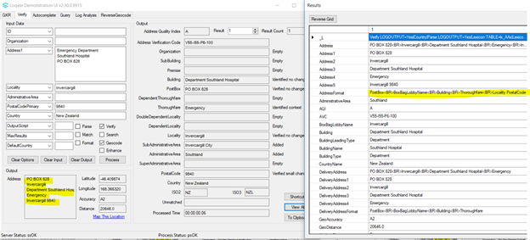  2019Q1.0 - Department is not in the address format. | 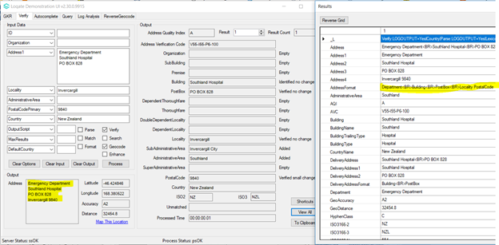  2019Q2.0 - Department is added. Postbox and BoxBagLobbyName is moved to the line after Building

Knowledge Base & Reference Data Updates
The table below shows which countries have been updated, and how, in this release.

- Reference Data = 182 countries
- Lexicons = 16 countries
- Context Rules = 7 countries

Country Name | ISO Code | Context Rules | Lexicons | Reference Data
AFGHANISTAN | AF |  |  | X
ÅLAND ISLANDS | AX |  |  | X
ALBANIA | AL |  |  | X
ALGERIA | DZ |  |  | X
AMERICAN SAMOA | AS |  |  | X
ANDORRA | AD
ANGOLA | AO |  |  | X
ANGUILLA | AI |  |  | X
ANTARCTICA | AQ
ANTIGUA AND BARBUDA | AG |  |  | X
ARGENTINA | AR
ARMENIA | AM |  |  | X
ARUBA | AW |  |  | X
AUSTRALIA | AU |  | X | X
AUSTRIA | AT
AZERBAIJAN | AZ |  |  | X
BAHAMAS | BS |  |  | X
BAHRAIN | BH
BANGLADESH | BD |  |  | X
BARBADOS | BB |  |  | X
BELARUS | BY
BELGIUM | BE |  |  | X
BELIZE | BZ |  |  | X
BENIN | BJ |  |  | X
BERMUDA | BM |  |  | X
BHUTAN | BT |  |  | X
BOLIVIA, PLURINATIONAL STATE OF | BO |  |  | X
BONAIRE, SINT EUSTATIUS AND SABA | BQ
BOSNIA AND HERZEGOVINA | BA |  |  | X
BOTSWANA | BW |  |  | X
Country Name | ISO Code | Context Rules | Lexicons | Reference Data
BOUVET ISLAND | BV
BRAZIL | BR
BRITISH INDIAN OCEAN TERRITORY | IO |  |  | X
BRUNEI DARUSSALAM | BN |  |  | X
BULGARIA | BG |  |  | X
BURKINA FASO | BF |  |  | X
BURUNDI | BI |  |  | X
CAMBODIA | KH
CAMEROON | CM |  |  | X
CANADA | CA | X | X | X
CAPE VERDE | CV |  |  | X
CAYMAN ISLANDS | KY |  |  | X
CENTRAL AFRICAN REPUBLIC | CF |  |  | X
CHAD | TD |  |  | X
CHILE | CL
CHINA | CN |  |  | X
CHRISTMAS ISLAND | CX |  |  | X
COCOS (KEELING) ISLANDS | CC |  |  | X
COLOMBIA | CO
COMOROS | KM |  |  | X
CONGO | CG |  |  | X
CONGO, THE DEMOCRATIC REPUBLIC OF THE | CD |  |  | X
COOK ISLANDS | CK |  |  | X
COSTA RICA | CR |  |  | X
CÔTE D'IVOIRE | CI |  |  | X
CROATIA | HR |  |  | X
CUBA | CU |  |  | X
CURAÇAO | CW
CYPRUS | CY |  |  | X
CZECH REPUBLIC | CZ |  | X | X
DENMARK | DK
DJIBOUTI | DJ |  |  | X
DOMINICA | DM |  |  | X
DOMINICAN REPUBLIC | DO
ECUADOR | EC
EGYPT | EG
Country Name | ISO Code | Context Rules | Lexicons | Reference Data
EL SALVADOR | SV
EQUATORIAL GUINEA | GQ |  |  | X
ERITREA | ER |  |  | X
ESTONIA | EE |  |  | X
ETHIOPIA | ET |  |  | X
FALKLAND ISLANDS (MALVINAS) | FK |  |  | X
FAROE ISLANDS | FO |  |  | X
FIJI | FJ |  |  | X
FINLAND | FI
FRANCE | FR |  | X | X
FRENCH GUIANA | GF |  |  | X
FRENCH POLYNESIA | PF
FRENCH SOUTHERN TERRITORIES | TF |  |  | X
GABON | GA |  |  | X
GAMBIA | GM |  |  | X
GEORGIA | GE |  |  | X
GERMANY | DE
GHANA | GH |  |  | X
GIBRALTAR | GI |  |  | X
GREECE | GR
GREENLAND | GL |  |  | X
GRENADA | GD |  |  | X
GUADELOUPE | GP |  |  | X
GUAM | GU |  |  | X
GUATEMALA | GT
GUERNSEY | GG |  | X | X
GUINEA | GN |  |  | X
GUINEA-BISSAU | GW |  |  | X
GUYANA | GY |  |  | X
HAITI | HT |  |  | X
HEARD ISLAND AND MCDONALD ISLANDS | HM
HOLY SEE (VATICAN CITY STATE) | VA |  |  | X
HONDURAS | HN |  |  | X
HONG KONG | HK
HUNGARY | HU |  |  | X
Country Name | ISO Code | Context Rules | Lexicons | Reference Data
ICELAND | IS |  |  | X
INDIA | IN
INDONESIA | ID
IRAN, ISLAMIC REPUBLIC OF | IR |  |  | X
IRAQ | IQ |  |  | X
IRELAND | IE
ISLE OF MAN | IM |  | X | X
ISRAEL | IL
ITALY | IT |  |  | X
JAMAICA | JM
JAPAN | JP
JERSEY | JE |  | X | X
JORDAN | JO |  |  | X
KAZAKHSTAN | KZ |  |  | X
KENYA | KE |  |  | X
KIRIBATI | KI |  |  | X
KOREA, DEMOCRATIC PEOPLE'S REPUBLIC OF | KP |  |  | X
KOREA, REPUBLIC OF | KR | X | X | X
KUWAIT | KW |  |  | X
KYRGYZSTAN | KG |  |  | X
LAO PEOPLE'S DEMOCRATIC REPUBLIC | LA |  |  | X
LATVIA | LV
LEBANON | LB |  |  | X
LESOTHO | LS |  |  | X
LIBERIA | LR |  |  | X
LIBYA | LY |  |  | X
LIECHTENSTEIN | LI
LITHUANIA | LT | X | X | PDH
LUXEMBOURG | LU |  |  | X
MACAO | MO
MACEDONIA, THE FORMER YUGOSLAV REPUBLIC OF | MK |  |  | X
MADAGASCAR | MG |  |  | X
MALAWI | MW |  |  | X
MALAYSIA | MY | X | X | PDH
MALDIVES | MV |  |  | X
MALI | ML |  |  | X
Country Name | ISO Code | Context Rules | Lexicons | Reference Data
MALTA | MT |  |  | X
MARSHALL ISLANDS | MH |  |  | X
MARTINIQUE | MQ |  |  | X
MAURITANIA | MR |  |  | X
MAURITIUS | MU |  |  | X
MAYOTTE | YT
MEXICO | MX
MICRONESIA, FEDERATED STATES OF | FM |  |  | X
MOLDOVA, REPUBLIC OF | MD |  |  | X
MONACO | MC |  |  | X
MONGOLIA | MN |  |  | X
MONTENEGRO | ME |  |  | X
MONTSERRAT | MS |  |  | X
MOROCCO | MA |  |  | X
MOZAMBIQUE | MZ
MYANMAR | MM |  |  | X
NAMIBIA | NA |  |  | X
NAURU | NR |  |  | X
NEPAL | NP |  |  | X
NETHERLANDS | NL
NEW CALEDONIA | NC |  |  | X
NEW ZEALAND | NZ |  | X | X
NICARAGUA | NI |  |  | PDH
NIGER | NE |  |  | X
NIGERIA | NG |  |  | X
NIUE | NU |  |  | X
NORFOLK ISLAND | NF |  |  | X
NORTHERN MARIANA ISLANDS | MP |  |  | X
NORWAY | NO
OMAN | OM |  |  | X
PAKISTAN | PK |  |  | X
PALAU | PW |  |  | X
PALESTINE, STATE OF | PS
PANAMA | PA
PAPUA NEW GUINEA | PG |  |  | X
PARAGUAY | PY |  |  | PDH
PERU | PE | X | X | PDH
Country Name | ISO Code | Context Rules | Lexicons | Reference Data
PHILIPPINES | PH | X | X | PDH
PITCAIRN | PN |  |  | X
POLAND | PL
PORTUGAL | PT |  | X | PDH
PUERTO RICO | PR |  |  | X
QATAR | QA
RÉUNION | RE |  |  | X
ROMANIA | RO |  |  | X
RUSSIAN FEDERATION | RU
RWANDA | RW |  |  | X
SAINT BARTHÉLEMY | BL |  |  | X
SAINT HELENA, ASCENSION AND TRISTAN DA CUNHA | SH |  |  | X
SAINT KITTS AND NEVIS | KN |  |  | X
SAINT LUCIA | LC |  |  | X
SAINT MARTIN (FRENCH PART) | MF |  |  | X
SAINT PIERRE AND MIQUELON | PM |  |  | X
SAINT VINCENT AND THE GRENADINES | VC |  |  | X
SAMOA | WS |  |  | X
SAN MARINO | SM |  |  | X
SAO TOME AND PRINCIPE | ST |  |  | X
SAUDI ARABIA | SA |  |  | X
SENEGAL | SN |  |  | X
SERBIA | RS |  |  | X
SEYCHELLES | SC |  |  | X
SIERRA LEONE | SL |  |  | X
SINGAPORE | SG
SINT MAARTEN | SX
SLOVAKIA | SK |  |  | X
SLOVENIA | SI |  |  | X
SOLOMON ISLANDS | SB |  |  | X
SOMALIA | SO |  |  | X
SOUTH AFRICA | ZA
SOUTH GEORGIA AND THE SOUTH SANDWICH ISLANDS | GS |  |  | X
SOUTH SUDAN, REPUBLIC OF | SS |  |  | X
SPAIN | ES | X | X | PDH
Country Name | ISO Code | Context Rules | Lexicons | Reference Data
SRI LANKA | LK |  |  | X
SUDAN | SD |  |  | X
SURINAME | SR |  |  | X
SVALBARD AND JAN MAYEN | SJ |  |  | X
SWAZILAND | SZ |  |  | X
SWEDEN | SE |  |  | X
SWITZERLAND | CH
SYRIAN ARAB REPUBLIC | SY |  |  | X
TAIWAN, PROVINCE OF CHINA | TW
TAJIKISTAN | TJ |  |  | X
TANZANIA, UNITED REPUBLIC OF | TZ |  |  | X
THAILAND | TH
TIMOR-LESTE | TL |  |  | X
TOGO | TG |  |  | X
TOKELAU | TK |  |  | X
TONGA | TO |  |  | X
TRINIDAD AND TOBAGO | TT |  |  | X
TUNISIA | TN |  |  | X
TURKEY | TR
TURKMENISTAN | TM |  |  | X
TURKS AND CAICOS ISLANDS | TC |  |  | X
TUVALU | TV |  |  | X
UGANDA | UG |  |  | PDH
UKRAINE | UA |  |  | X
UNITED ARAB EMIRATES | AE |  |  | X
UNITED KINGDOM | GB |  |  | X
UNITED STATES | US |  |  | X
UNITED STATES MINOR OUTLYING ISLANDS | UM |  |  | X
URUGUAY | UY |  | X | X
UZBEKISTAN | UZ
VANUATU | VU |  |  | X
VENEZUELA, BOLIVARIAN REPUBLIC | VE |  |  | X
VIET NAM | VN
VIRGIN ISLANDS, BRITISH | VG |  |  | X
VIRGIN ISLANDS, U.S. | VI |  |  | X
WALLIS AND FUTUNA | WF |  |  | X
Country Name | ISO Code | Context Rules | Lexicons | Reference Data
WESTERN SAHARA | EH
YEMEN | YE
ZAMBIA | ZM
ZIMBABWE | ZW

Installation Instructions
The 2019Q2.0 release makes improvements to the performance of the verification process and the quality of the results.

Please remember to update both the program files and the reference data. The improvements are tied to the data in the Global Knowledge Repository and the Local API. If you need any assistance with the upgrade of the Local API or the data update process, please contact GBG Loqate Support.

The setup wizard for the Local API can be obtained from our SFTP server. Please contact your account manager to retrieve the SFTP information. If you do not know who your account manager is, please contact the support team at support@loqate.com.

GBG Loqate data packs can be downloaded and installed using the Install Manager. This is a component you will need to select during the installation of the Local API as shown below.

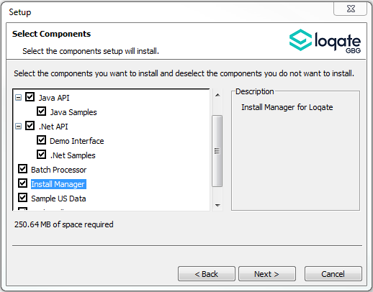

Standard GBG Loqate Installation (Multi-threaded)
- Download the contents of the 2019Q2.0/AppInstaller directory.
- Check the MD5 checksums to ensure that the download has been successful.
- Run the relevant Loqate Local API installer. Please note you may need to add execute privileges to the relevant installer when using Linux. Make sure the option “Install Manager” is selected for installation.
- Execute the Install Manager script (InstallManager.bat on Windows and InstallManager.sh on other Linux/Unix platforms) and install the data. For further details, please review the 2019Q2.0 Installation Instructions document.
- Run the relevant Global Knowledge Repository installer. Please note you may need to add execute privileges when using Linux.

Single-threaded GBG Loqate Installation
- Download the contents of the 2019Q2.0/STAppInstaller directory.
- Check the MD5 checksums to ensure that the download has been successful.
- Run the relevant Loqate Local API installer. Please note you may need to add execute privileges to the relevant installer when using Linux. Make sure the option “Install Manager” is selected for installation.
- Execute the InstallManager script (InstallManager.bat on Windows and InstallManager.sh on other Linux/Unix platforms) and install the data. For further details, please review the 2019Q2.0 Installation Instructions document.
- Run the relevant Global Knowledge Repository installer. Please note you may need to add execute privileges when using Linux.

SFTP Server Contents
On the GBG Loqate SFTP server, you will find the following items:
- AppInstaller: The folder which contains the Loqate Local API installer
- loqate_installer_aix: The AIX Loqate Local API installer
- loqate_installer_hpux: The HP-UX Loqate Local API installer
- loqate_installer_solaris_x86: The Solaris x86 Loqate Local API installer
- loqate_installer_sparc: The Solaris SPARC Loqate Local API installer
- loqate_installer_x86: The Linux 32-bit Loqate Local API installer
- loqate_installer_x86-cpp5: The Linux 32-bit C++ v5 Local API Loqate library installer
- loqate_installer_x86_64: The Linux 64-bit Loqate Local API installer
- setup.exe: The Windows 32-bit Loqate Local API installer
- setup_x64.exe: The Windows 64-bit Loqate Local API installer
- AppInstaller-md5.txt : Contains the checksums of the files in the folder
- STAppInstaller: The folder which contains the Loqate Local API installer for single-threaded libraries
- loqate_installer_aix: The AIX Loqate Local API installer
- loqate_installer_hpux: The HP-UX Loqate Local API installer
- loqate_installer_solaris_x86: The Solaris x86 Loqate Local API installer
- loqate_installer_sparc: The Solaris SPARC Loqate Local API installer
- loqate_installer_x86: The Linux 32-bit Loqate Local API installer
- loqate_installer_x86-cpp5: The Linux 32-bit C++ v5 Local API Loqate library installer
- loqate_installer_x86_64: The Linux 64-bit Loqate Local API installer
- AppInstaller-md5.txt : Contains the checksums of the files in the folder
- STAppInstaller-md5.txt : Contains the checksums of the files in the folder
- OSGi: The folder which contains the OSGi bundle for the Loqate Local API
- loqate-osgi-1.0.0.0.jar: The OSGi bundle for Loqate Local API installer
- osgi-md5.txt: Contains the checksums of the files in the folder
- Rawfiles: The folder which contains the Loqate Local API files in the following subfolders
- aix: The AIX Loqate Local API library files
- hp-ux: The HP-UX Loqate Local API library files
- solaris_x86: The Solaris x86 Loqate Local API library files
- sparc: The Solaris SPARC Loqate Local API library files
- linux32: The Linux 32-bit Loqate Local API library files
- linux32-cpp5: The Linux 32-bit C++ v5 Loqate Local API library files
- linux64: The Linux 64-bit Loqate Local API library files
- win64: The Windows 32-bit Loqate Local API library files
- win32: The Windows 64-bit Loqate Local API library files

Need Help?
Many answers to your questions may be found in our support pages. For full access to the technical information provided on our website, please make sure to register at:
http://support.loqate.com/wp-login.php?action=register

- Support Home Page: http://support.loqate.com
- Local APIs: http://support.loqate.com/support/local-apis/
- Field Descriptions: http://support.loqate.com/support/fielddescrip/
- Server and Process Options: http://support.loqate.com/support/options/
- System Requirements: http://support.loqate.com/system-requirements/
If you have any general questions, issues, or enhancement request you’d like to share with us, please fill out our case submission web form at http://support.loqate.com/support/file-a-case/.

